**INTRODUCTION**

The “microblogging” social networking website “Twitter” has a huge and quickly growing user base. Twitter are those wherein we can write short can write short 140 characters long or less named “tweets”. Tweet is the process in which we follow the people and their message as’ tweets’. Owing to the increasing popularity of the website, “tweet” can be collected in the form of large data set from website. Twitter has special features that permits persons to carry their ideas and opinions openly about so forth subject, conversation topic or product that they are attracted in spreading their sentiments about twitter. As a result Twitter is a decent medium to examine on behalf of supposedly motivating tendencies about noticeable themes in the news or popular tradition. The application is built for the purpose of analyzing data, although Rstudio performs well with the statistical problems and proceeds with a user friendly interface.

Twitter text analysis generate a means of following feelings and approaches on the web and determines if they are positively or negatively received by the followers. This project will develop and determine whether the tweet status updates (which is not more than 140 characters) returns a positive or negative opinion on the behalf of the one who tweeted which is done by the classification model. Allowing the application of various data mining algorithms to explain the textual dataset, the determination of Text mining is method for unstructured (textual) information and to extract meaningful numeric indices from the text.

Twitter text analysis refers to the use of normal language processing, computational semantics and text analysis to recognize and specific information from the dataset. Twitter has grown its value in recent years has been rising in political, industrial taking place to analyze the public’s groups and interested Internet users have common emotion for their products and services from the twitter posts.

**1.1 Project description**

Twitter now-a-days, is most popular than compare to any other social networking sites like, Facebook, LinkedIn and YouTube. Current growth in wide-area network connectivity potential has enormously grown opportunities for resource sharing and collaboration. Other social media have expanded so much popularity and we cannot refuse them. Other social media also have become the most important applications on Web. Twitter have shaped the creation of matchless public collection of sentiments about every worldwide entity that is of notice. It is obvious that the arrival of these real-time information networking sites like twitter may provision for an exceptional system for decision creation and presentation, it also poses challenges and the process which is incomplete without expert tools for analyzing those sentiments to accelerate their implementation of ideas with newer and different opinions.

**1.2 Motivation**

To analysis tweets this project choose with the hash tag #Dhoni and #IPL2015 as these are relevant for data collection at that time. Dhoni is one of the most popular and his CSK teams always in frame so it is totally about popularity with comment and tweets reaction from the follower and sentiment score with tweet review is handier for his CSK team popularity.

Dhoni represented India and he was the most popular player of 2015 in India. This project is used to examine the tweets related to Dhoni and the CSK team 2015 as most popular among the other IPL teams in India.

Dhoni has been always the main center for attraction among the people which his popularity and his tweets can be analyzed with positive and negative from the opinion of his followers comment and likes.

**1.3 Aims**

For analyzing of data or to perform text mining first we have to conduct any kind of construction for a suitable dataset we have to build API.API of twitter is an interface between the twitter apps (created by user) and the Rstudio integration by its package and function which is specific tool for loading tweets from twitter in Rsudio. To construct a database of tweets on the keywords #IPL2015 and #Dhoni that is to be build using a Twitter API app is the aim of this paper.

Machine learning techniques will regulate the number and score of tweets which are positive and negative. The result of those machine learning techniques is used to confirm text analysis of the dataset. The knowledge based techniques that will achieve a series of analysis on the data which uses a sentiment lexicon dictionary to regulate the number of positive and negative tweets that will be executed in Rstudio.

**1.4 Structure**

Associated work defines the associated literature that is revised everywhere in the topic of text mining and sentiment analysis and different methodologies has been used. The overall layout of the project will be achieved by Design and Architecture that describes how the design of the project is based on Bayesian classifier which is described in this section. In Architectures figure provides a pathway design of the different distribution systems that will be used and that how they are associated to other systems. Application provides a step by step guide through the processes of the project which contains the code that was used as input as well as outputs..

This section defines the datasets used in this project. It also describes in detail how the data was picked up and the basic report of the data. It refer to where it is kept and how it will be used to answer the aims of the project. Requirements provide the aspects of the project that must be measured such as Functional requirements, Data requirements, User requirements etc. Datasets.

**2. RELATED WORK (Literature Review)**

The area of Text Mining for sentiment analysis proposes to understand the opinions are distributed among them into the different categories of emotion like positive, negative, neutral. Generally most of the sentiment analysis work has been done on review sites till now. Review sites deliver with the sentiments of for business to analyze stock or any match review, thus restricting the domain of application is for specially business and other prediction. Thus, the venture into the corpus of twitter API allows us to move into different extents and various applications. The most common applications of sentiment analysis is to refine from data alike emotion, attitudes and feelings on the internet, especially for tracking products, services, brands or even people.

Twitter posts in the field of sentiment analysis, is the next step as tweets give us a better and more diverse data resource of opinions and sentiments that can be whatever like the latest phone they bought, movie they watched, political issues, religious views or the individuals state of mind by extract tweets from twitter API.

As we can imagine twitter is one of the most common applications is to track attitudes and feelings on the web for sentiment analysis, especially for tacking products, services, brands or even people Sentiment analysis is also stated as Text or Opinion Mining that implies by extracting opinions, emotions and sentiments in text. The main idea is to analyze whether they are viewed positively or negatively by a given viewers.

**2.1 Symbolic Techniques**

Symbolic techniques makes use of existing lexical resources is controlled by classification models. It is used for bag-of-words tactic in sentiment analysis. In this tactic the collection of words where are associations between words that are not considered important. The document is treated to determine the global sentiment. Those values are combined in sentiments of every word that are given for value and using combination of functions where tuples are phrases having positive or negative feelings may be considered as adjectives or adverbs which the polarity of words are found as review was extracted from the review based in the average semantic orientation of tuples.

**2.2. Machine Learning Techniques**

The Knowledge based methods are not depended on lexicon dataset for Machine Learning technique, In this methodology test set are in order to classify an employed, instead the use of a training set. In classification model it is developed by set of methodology using a training set, which tries to classify the input feature as vectors into matching class labels. The face of every changing social network language lexicons allows the algorithm to remain dynamic in nature.

The class labels of hidden feature vectors are drawn in the training set as test set is used to verify the models by predicting. Support Vector Machines (SVM) and Bayesian classifier are used to classify reviews into either positive or negative orientation in number of machine learning techniques.

**2.3. Map Reduce Concept**

**Pig in Hadoop**

Hadoop is processing system. Pig executes on Hadoop. The Hadoop Distributed File System makes use of both *HDFS* and, *Map Reduce*.

A distributed file system that stores files on all of the nodes in a Hadoop cluster is said to be HDFS. The file are handles by distributing them across different machines by breaking it in the files into large blocks. It handles file including multiple copies of each block so that if any one of machine fails no data is lost. By default, Pig reads input files from HDFS and used HDFS to store intermediate data between Map Reduce jobs, and writes its output to HDFS. As we will see it can also read input from and write output to sources other than HDFS. It grants a POSIX-like interface to users in HDFS.

A simple but the powerful parallel data-processing paradigm is said to be Map Reduce. There are commonly three main stages: map, shuffle, and reduce in every job in Map Reduce which consists of data. The application has the prospect to work on each record in the input individually in the map phase. The map phase can generally be accomplished in one minute because if any maps are started at once it can input file size of gigabytes (GB) or terabytes (TB) in machines.

**3. SYSTEM AND DATASETS**

**3.1 Design and Architecture**

The proposed for this project to show system design that is shown in Figure 1. The sentiment orientation of the tweets are accessed through a Twitter API. The knowledge based methodologies and machine learning based methodologies is used to analysis the two methods for suggesting hybrid tactics. The words were scored from the internet and was openly available which was sourced into their relative sentiment orientation using a sentiment lexicon. The words which were extracted and stored in a feature vector. Feature extraction is used by machine learning algorithm that was produced from the test set-feature extraction. From the training set a Bayesian classifier was produced as in the form of model classifier. The associations between features such as emotional keywords and emoticons of Bayesian classifier does not consider in R. The collected reviews are used in R and it is saved to an excel file with .csv file and corpus was produced the excel file was then entered into the corpus was then separated into a training set and a test set and feature were extracted from each respectively. These features do not always relate with the use of a smiley emoticon at the end of a negative tweet. It is ideal for sentiment analysis as often to one another such as in Bayesian Classifier analyzes each of the features of the feature vector individually as it assumes that they are equally independent of each other. The conditional probability for Bayesian can be defined as

P (X |yj) = m

P (xi |yj)

’X’ is the feature vector defined as X={x1, x2, xm} and yj is the class label.

There are unlike many features such as emoticons, emotional keyword, which are treated as either positive or negative and utilized by Bayesian classifier for classification from the tweets that was collected for this project.

**3.2 Analysis and Design**

Social media analysis using both R and Hadoop. Data collection of tweets from dataset collection of tweets in R directly from twitter account through twitter application

**Design**

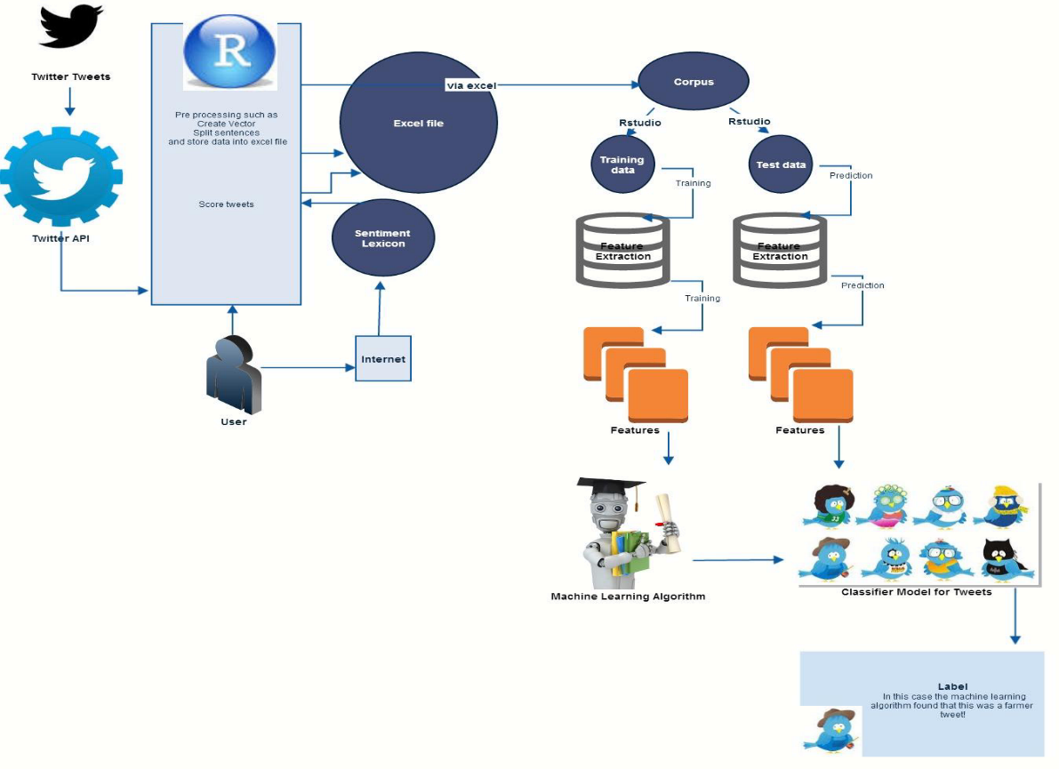

Figure 1

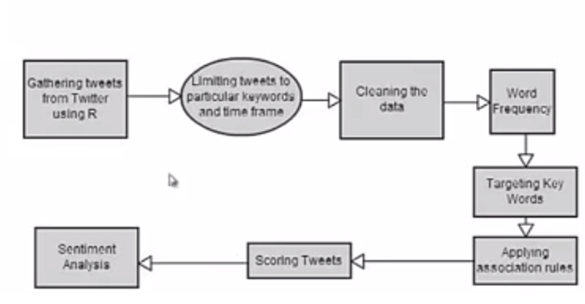

Figure 2

Collection of tweets from dataset

Collection of tweets in R directly from twitter account through twitter application

HADOOP

Map reduce:

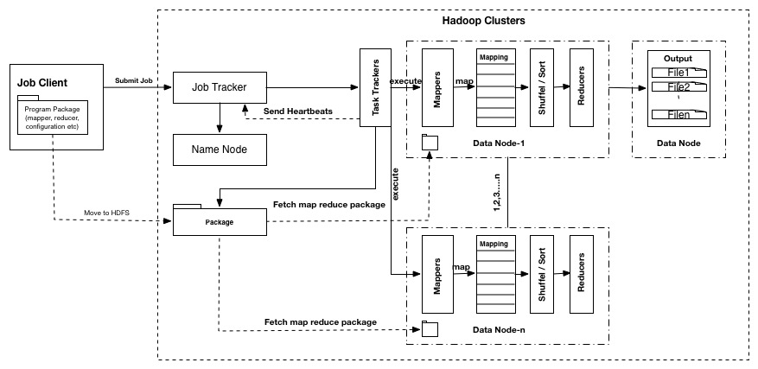

**Figure 3**

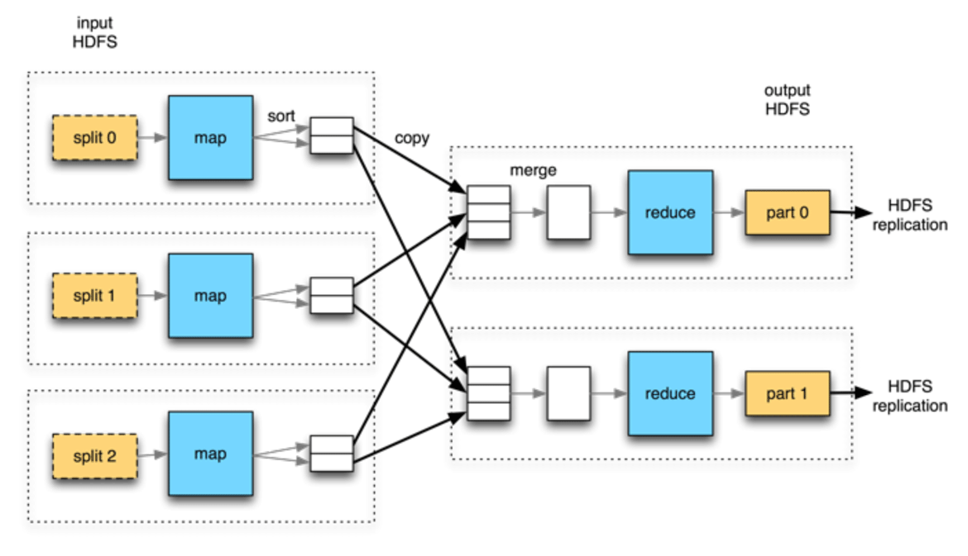

**Figure 4**

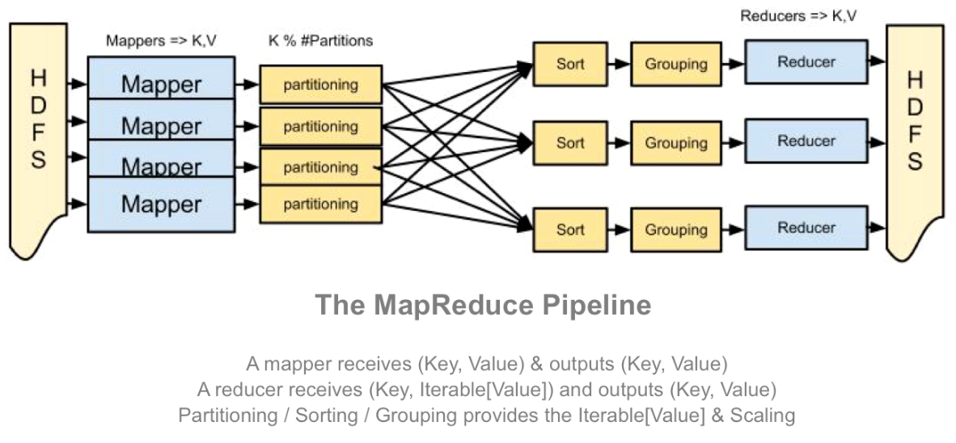

**Figure 5**

**4. IMPLEMENTATION**

**4.1 R programming language**

A software environment for [statistical computing](http://en.wikipedia.org/wiki/Statistical_computing) and graphics. For developing [statistical software](http://en.wikipedia.org/wiki/Statistical_software) and data analysis the R language is broadly used among [statisticians](http://en.wikipedia.org/wiki/Statistician) and [data miners](http://en.wikipedia.org/wiki/Data_mining) . R is an independent, open-source, and free implementation of the S programming language.  The [source code](http://en.wikipedia.org/wiki/Source_code) for the R software environment is written primarily in [C](http://en.wikipedia.org/wiki/C_(programming_language)), [FORTRAN](http://en.wikipedia.org/wiki/Fortran), and R. It is a public-domain implementation of the widely regarded S statistical language, and the R/S platform is a de facto standard among professional statisticians. It is available for the Windows, Mac, and Linux operating systems. In addition to providing statistical operations, R is a general purpose programming language, so you can use it to automate analyses and create new functions that extend the existing language features. All of your basic data analysis: descriptive statistics, linear regressions, logic, probability, duration model, etc. Programming your own estimators and statistical models.

Tools and Packages used in R:

In this project “Twitter Analysis using R” I have used RStudio GUI and following packages:

**twitteR:** The Twitter web API that provides an interface.

**ROAuth**: It provides an interface to the OAuth 1.0 specification. This package allows users to connect the server of their choice and authenticate via OAuth package.

**plyr**: It is a set of tools that solves a common set of problems: we need to break a big problem down into manageable pieces, operate on each pieces and then put all the pieces back together.

**stringr:** It is a set of simple packages that make R's string functions more reliable, simpler and easier to use. It does this by confirming that: argument and names (and positions) are dependable, all functions deal with NA's and zero length character properly, and the output data structures from each function matches the input data structures of other functions.

**ggplot2:** It is an implementation of the grammar of graphics in R. We can build up a plot step by step from numerous data sources. It bind and gains both base and lattice graphics: conditioning and shared axes which are controlled automatically.

**RColorBrewer**: This package offers palettes for sketching nice maps shaded according to a variable.

**tm**: it is a framework for text mining applications inside R.

**wordcloud***:* This package supports in creating pretty viewing word clouds in Text Mining.

**sentiment***:* It is a R package with tools for sentiment analysis including Bayesian classifiers for positivity/negativity and emotion classification.

**3.2 Creating a Twitter Application**

First step to implement Twitter Analysis is to create a twitter application. This application will permit you to perform analysis by linking your R console to the twitter using the Twitter API. The steps for creating your twitter applications are:

By using this link <https://dev.twitter.com> and login by using your twitter account.

Then go to My Applications 🡪 Create a new application.

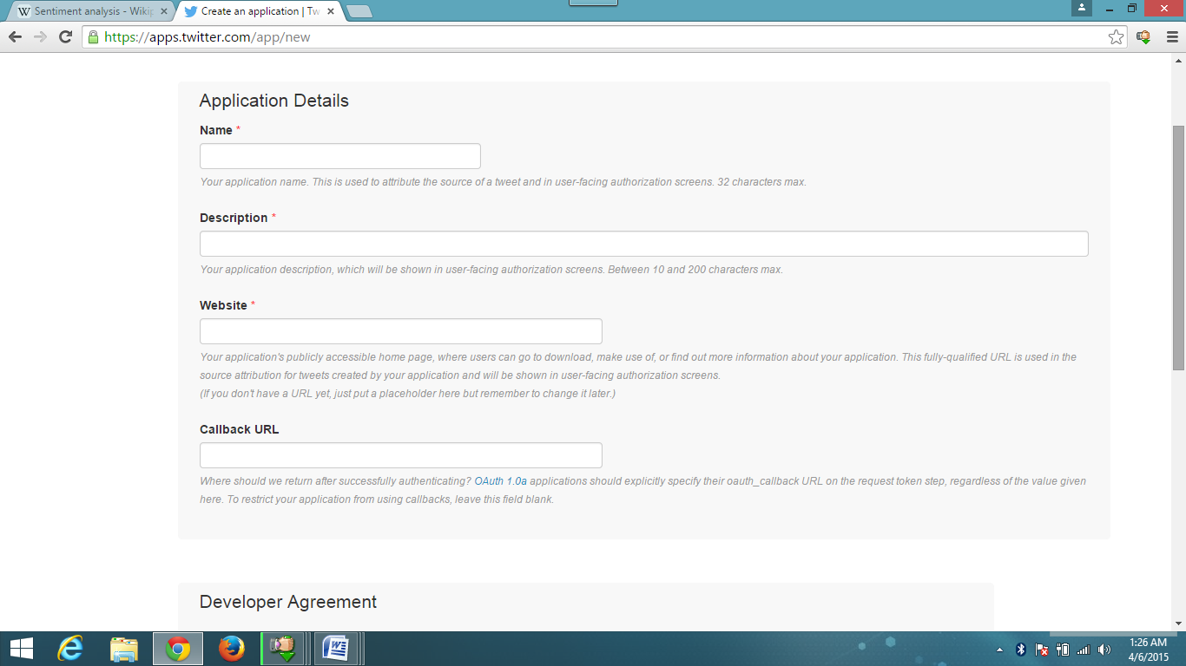

Steps to be followed: first give your application a name, give description about your application in limited words not more than i.e. (10) . Name your website’s URL or your blog address (in case you don’t have any website). No need to fill the Callback URL leave blank for now. Complete other regulations and create your twitter application. Once, all the steps are done, the created application will show as below. Please note the Consumer key and Consumer Secret numbers as they will be used in Rstudio later.

Like this your App will be created as shown below in pic.

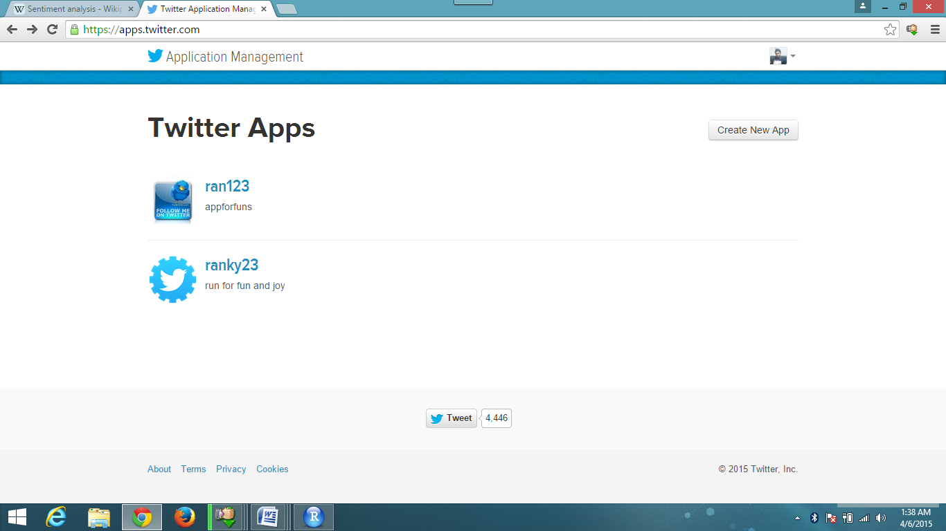

Now open the app and notice your app will have following token that are to be used later step.

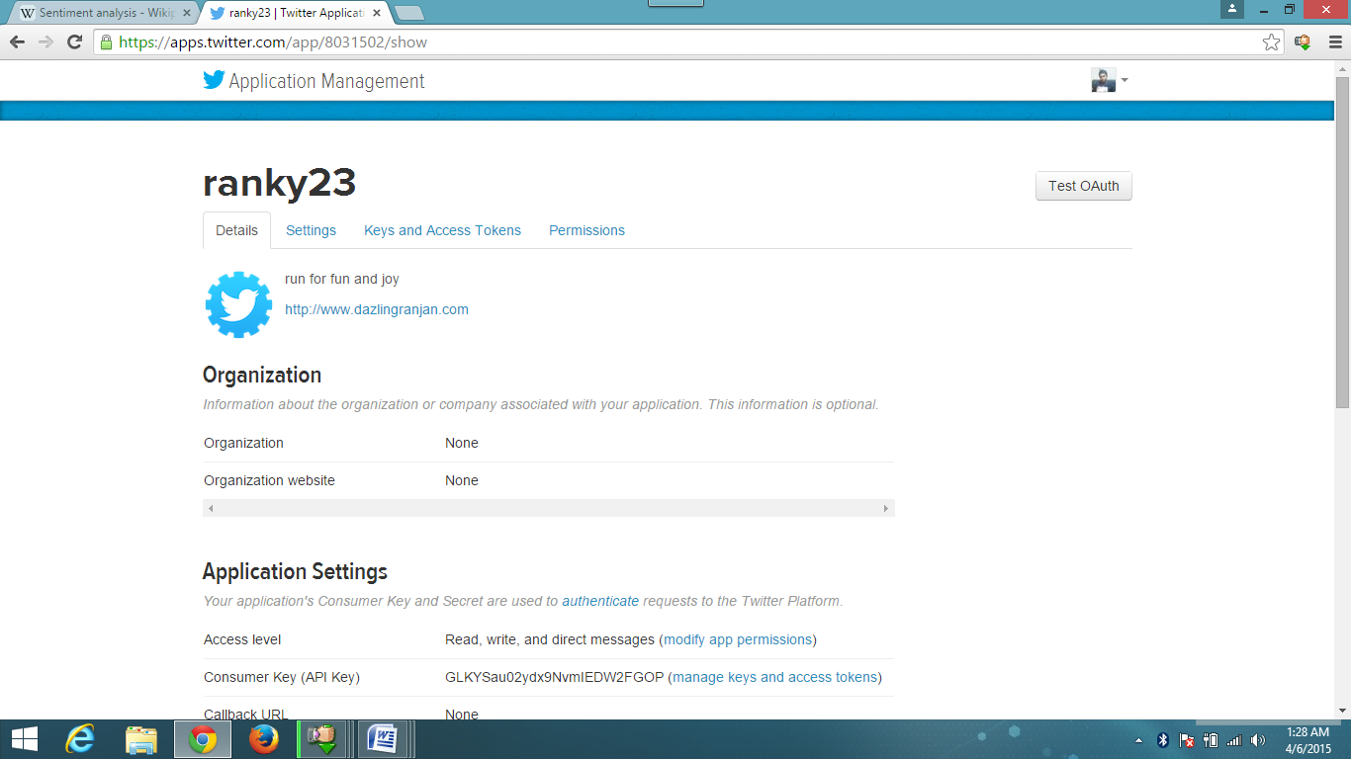

This step is finished. Next, I will go on my RStudio.

RStudio- Building the corpus example:

In this segment, I will initially use some packages in R. These are twitter, stringr, RCurl, ROAuth, plyr and ggplot2. We will install those packages by the following commands in R console

*#installing packages*

>install.packages(c("twitteR","RCurl","RoAuth","stringr","RJSONIO","plyr"),dependencies=T)

Execute this following R script code clip

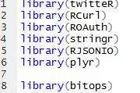

After executing the script section, console will look like this shown below:

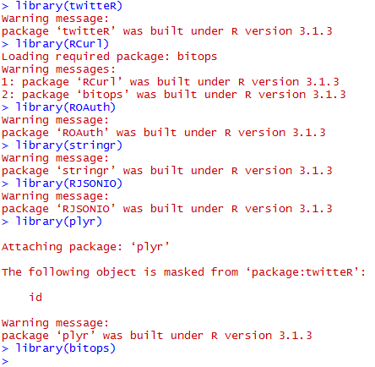

Sorry, But if you are installing you will not get warning it is due to directory I am getting warning. So you can continue further.

We are now heading on to reading the twitter API. Now once this file is installed this step will contain the script code to make handshake using the ConsumerKey and ConsumerSecret number of your own application. You have to make change those items by the keys from your application. Following is the code you have to execute to complete handshake.

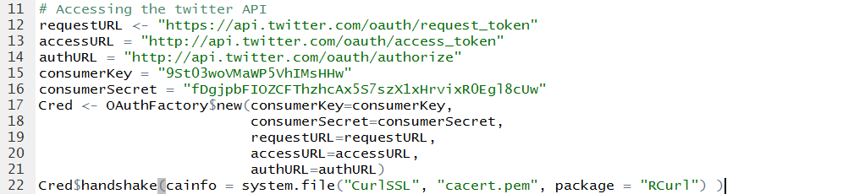

Here, see above line number 12, 13 and 14 will assign the requestURL, accessURL and authorizationURL of twitter application to the variables requestURL, accessURL and authURL respectively. consumerKey and consumerSecret are unique to a twitter application. Executing this provides message on the R console:

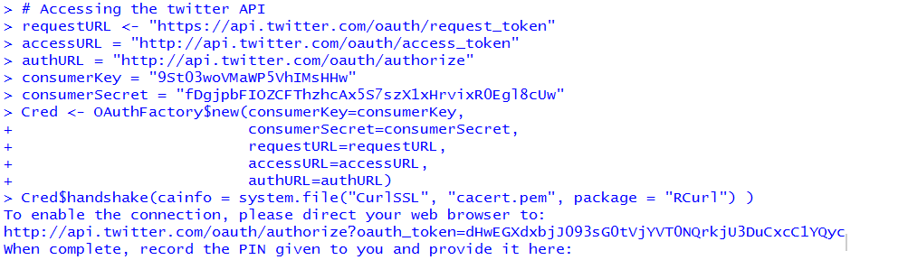

In the console we will see message to the user that three lines. To enable the connection, please go thru your web browser to:

https://api.twitter.com/oauth/authorize?oauth_token=dMwEGXdxbjJ093sG0tVjYVT0NQrkjU3DuCxcC1YQmc

After clicking the above link in your browser, authorize application by providing your username and password and the app will be authorized. You will get a code like this:

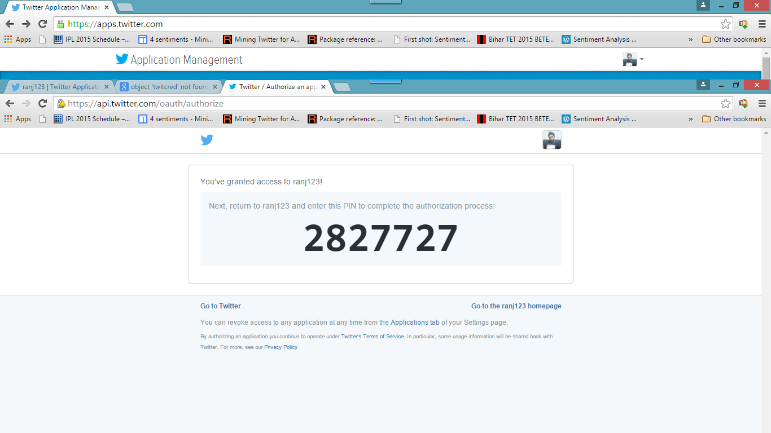

The console will provide a message like this. Write this code in the console



Now you can register the handshake by following command



Here console will send a message with TRUE, which means that the handshake is complete. Now we can get the tweets from the twitter timeline.

3.3 Extracting and Saving Tweets

We get our data in three steps. First we get the user object, then we get the followers and friends of this user and then we merge it to a data frame containing all these users and their information.

The query has multiple operators and will behave in the find following way:

Example:

|  |
| --- |
| Behavior |
| will find tweets containing both "IPL2015" and "Dhoni"; not case sensitive |
| will find tweets containing the exact phrase "Dhoni "; not case sensitive |
| will find tweets containing either "IPL2015" or "Dhoni" or both; not case sensitive; the OR operator IS case sensitive. |
| will find tweets containing "Dhoni" but not "IPL |

If the handshake is complete and authorized by twitter, we can get most recent tweets associated to any # tag or keyword. I have used #IPL as IPL8 is the most popular game in India and people talk about each match with their favorite teams and players they support.



The command for receiving tweets associated to #IPL2015 is:

This code will receive 100 tweets associated to PEPSI IPL2015. This function “search Twitter” is used for downloading tweets from the twitter timeline. Now we have to convert this list of 100 tweets into the data frame, so that we can perform in it. Then lastly we convert the data frame into .csv file

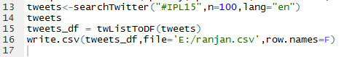

A snapshot of the csv file is given below. The ranjan.csv file got converted.

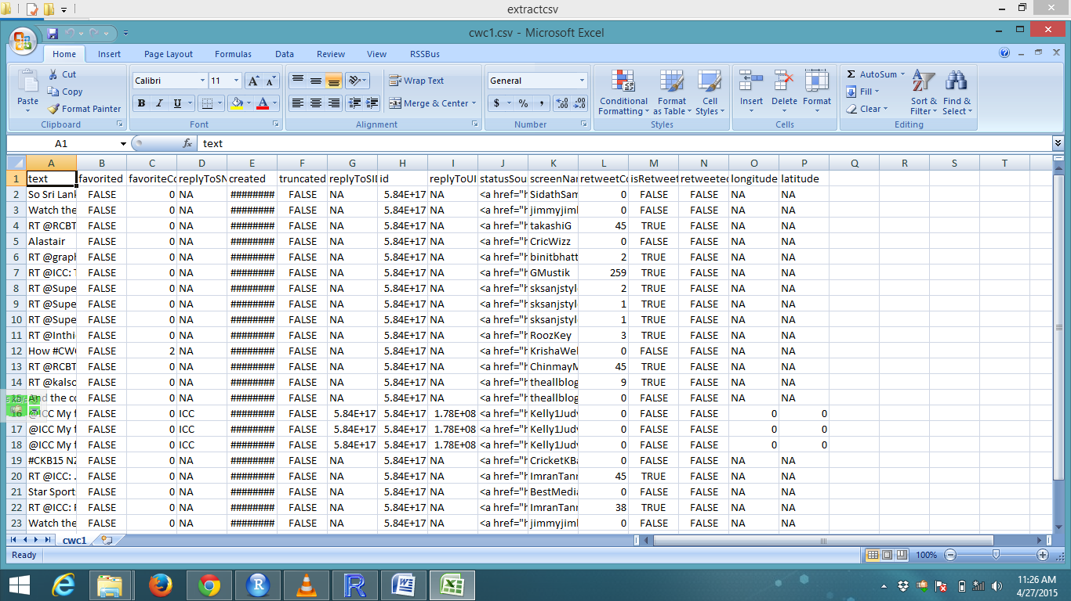

**3.4 Text Minining:**

**Corpus**

A corpus is a collection of texts, usually stored electronically, and from which we perform our analysis.

For handling documents in tm is a so-called Corpus, it is an abstract concept, and it can exist numerous operations in parallel, text documents signify a collection of document. A semantics as identified from most R objects: corpora are R objects deployed fully in memory which realizes the default operation so-called VCorpus (short for Volatile Corpus). The R object is destroyed, if whole corpus is gone because it is volatile. The constructor VCorpus(x, readerControl) can be created via volatile corpus.

**Corpus Sources and Readers**

There are a variety of sources supported by tm. We can use getSources ()

In addition to different kinds of sources of documents, our documents for text analysis will come in many different formats.

A text document from elements brought by a source which is the first part reader constructs. The termed components reader and language has to be a list with in the next argument readerControl of the corpus constructor. The tm package sends with numerous readers (e.g., readPlain (), readPDF (), readDOC () . . .). See get Readers () for an up-to-date list of existing readers. A default reader which can be overridden by each source. E.g., for DirSource the default just reads in the inputles and takes their content as text.

Lastly, the second component language sets the texts' language (rather using ISO 639-2 codes).

**Inspecting Corpora**

The raw volume of info (consider a corpus can contain of numerous documents, like a database) Custom print () methods are available which hide. Text documents is presented with inspect () and Print () provides a brief overview with the full content.

**Transformations of Text Mining**

Mostly, transformations work on a single text documents and tm map () just applies them to all documents in a corpus. To make change in the documents in it we have a corpus and normally we want, e.g., criteria, stop word, stemming, removal. The concept of a transformation is considered into tm for all this functionality. ) The function to all elements of the corpus are done with the tm_map () function which is applied in transformations (maps).

The tm package come from map function called tm. Several commands are understandable: strip unnecessary white space, remove e.g.: English common words like ‘the’ (so-called ‘stop words’),transmit the [text stemming](http://en.wikipedia.org/wiki/Stemming) for the ending tidy-up and alter everything to lower case (otherwise highlighted capitalized words are separated by wordcloud . We can also explicitly remove numbers and punctuation with the remove Numbers and remove Punctuation arguments

* Removing Extra Whitespace
* Transform to Lower Case
* Remove number
* Remove punctuation
* Remove URL

**4.5 Stemming Text**

In R, load the SnowballC package, along with twitteR, and tm. The SnowballC package will allow us to stem our text of tweets. The tweets corpus data was created in the previous post.   
After creating a copy of the tweets corpus for a reference prior to the stemming changes, we can proceed with the stemming. With the tm_map () function, use the stemDocument transformation. Inspect the documents in the text corpus with the  inspect () function.

**Creating Term-Document Matrices**

To create a term-document matrix from a corpus a common approach is by text mining. In the tm package the classes TermDocumentMatrix and DocumentTermMatrix (subject to whether we want terms as columns and documents as rows) sparse matrices for corpora are employ.

In a term document matrix, the terms are the rows and the documents are in the columns. We can also create a document term matrix, and that would simply be the transpose of the term document matrix- the documents are represented by the rows and the terms by the columns.

**Wordcloud**

The finest tools that lets us to visualize maximum of the words and terms contained in tweets can be done with wordcloud. The advantage to be understandable by most users, and to be visually eye-catching to the human (if done suitably).Though it is used for exploratory purposes.

**Steps**

* Downloading some tweets via twitteR API.
* Then extract the text from the tweets.
* Make some text manipulation (for formatting & cleaning).
* Make a TermDocumentMatrix (via tm) and a lexical Corpus.
* Get words and their frequencies.
* Then plot the wordcloud.

**4.6 Coding:**

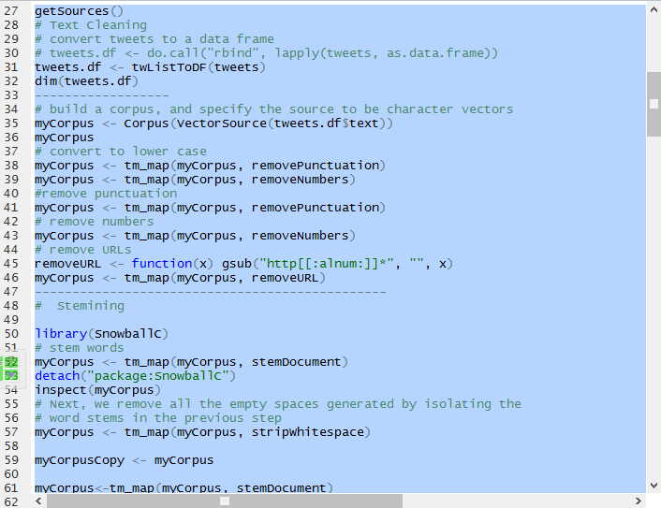

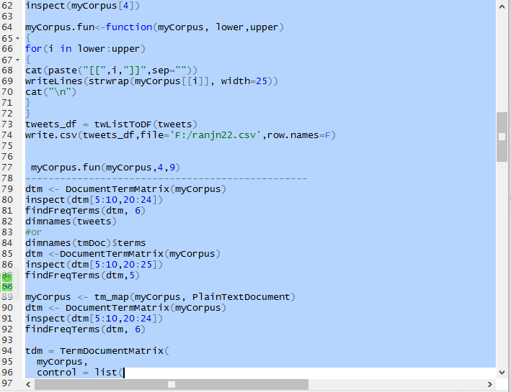

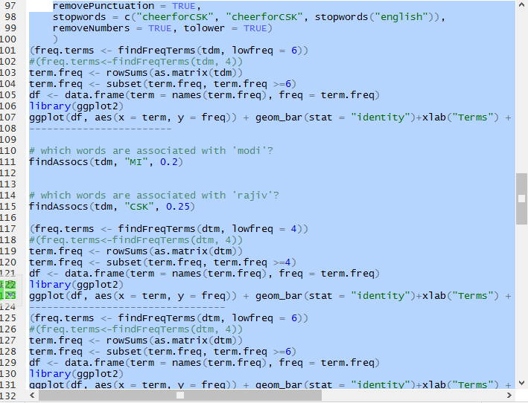

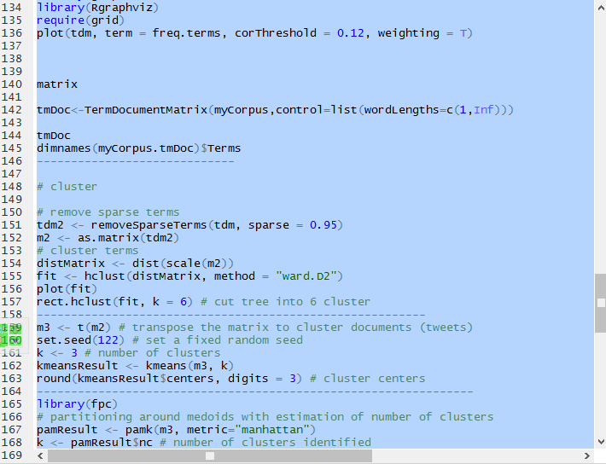

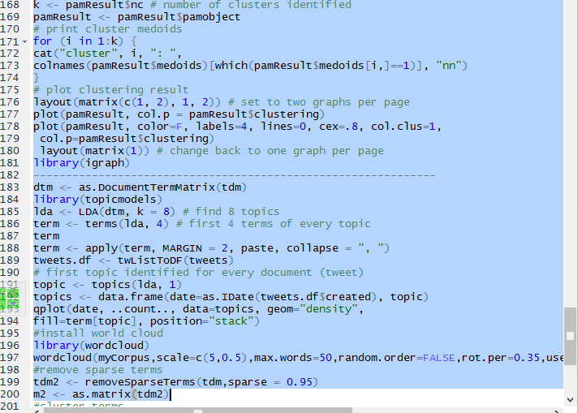

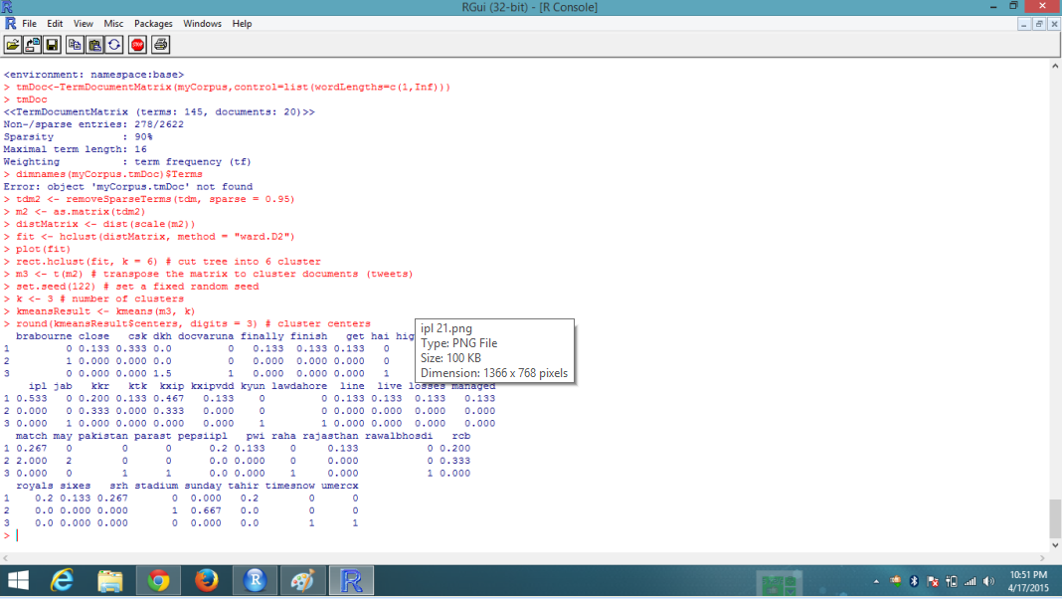

Now plot Cluster:

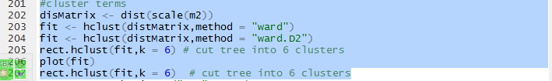

Different Plotted result:

Histogram:

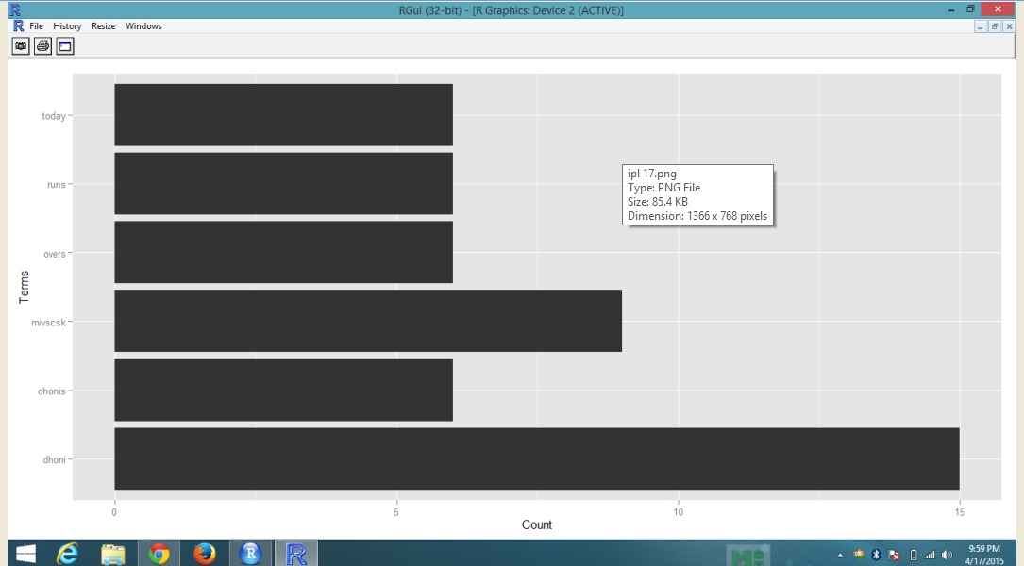

Second Related Network from matrix:

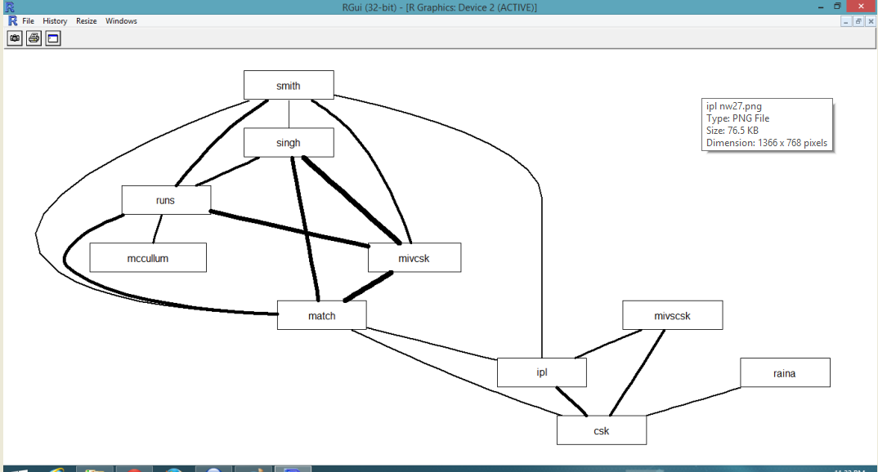

Third Wordcloud from matrix:

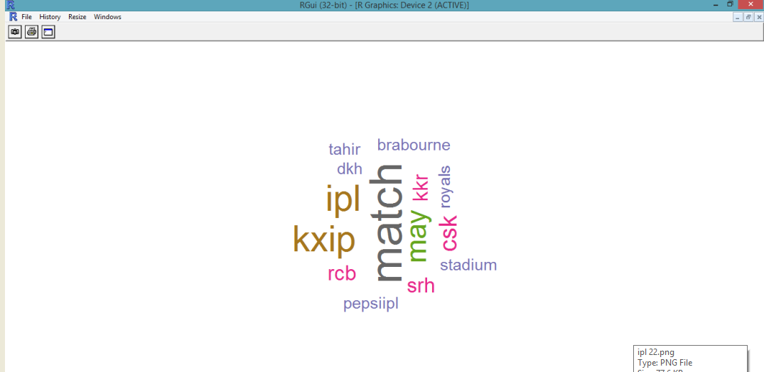

After that we will get different Cluster:

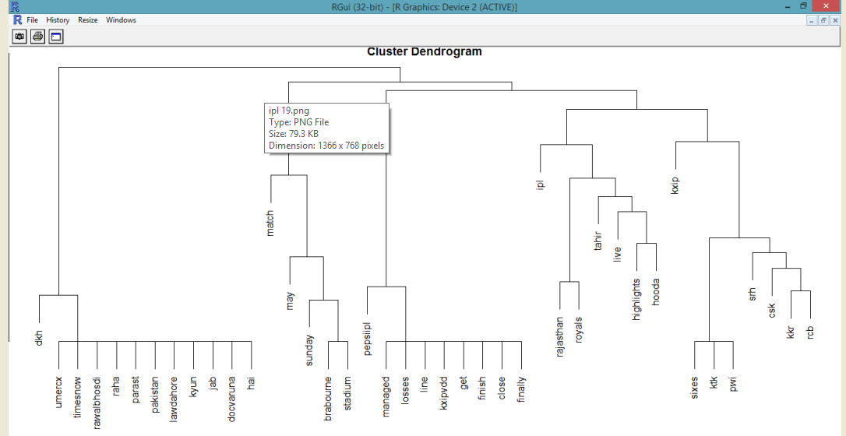

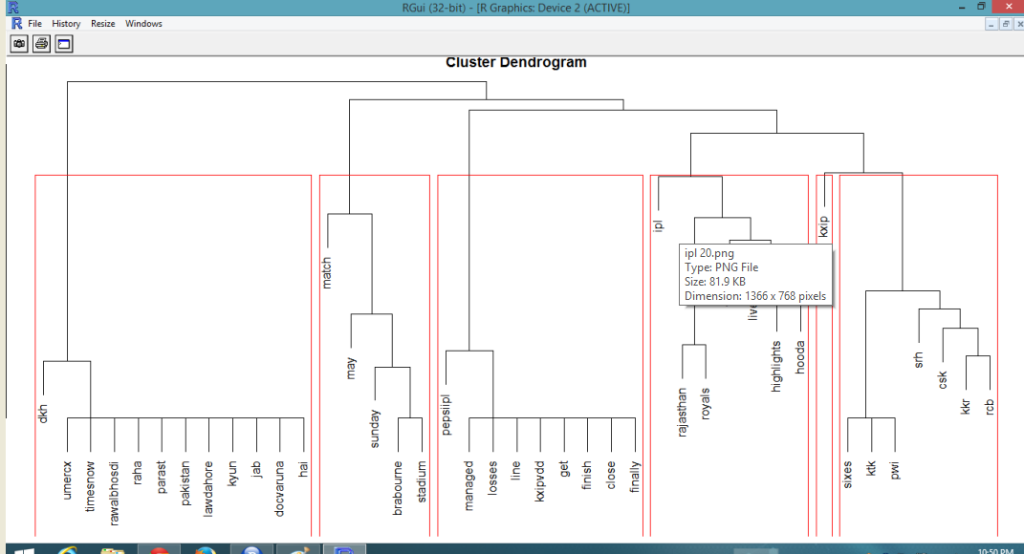

Wordcloud Cluster:

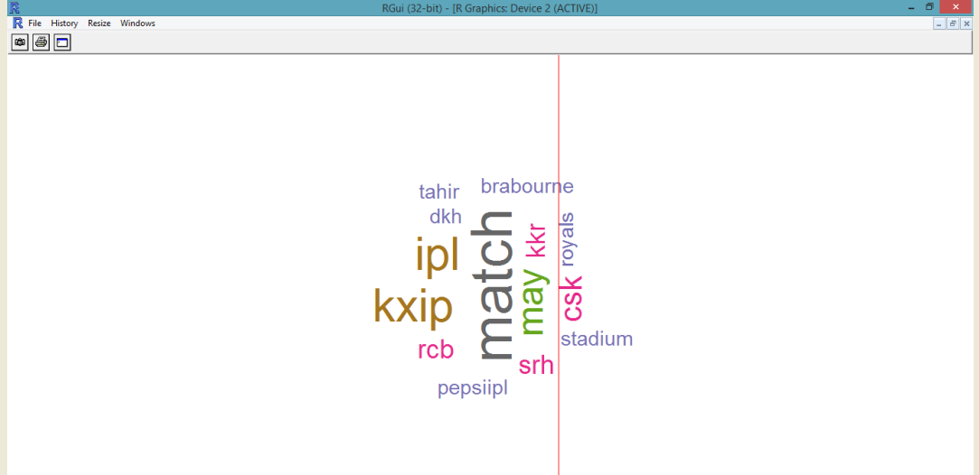

**4.7 Sentiment Analysis:**

The main functioning norm of sentiment analysis is to search the words from the tweets that characterize positive sentiments and catch the words from the tweets that characterize negative sentiments. When we have the tweets we just need to put on some functions to convert these tweets into some proper information. In place of this we need a collection of words that has positive and negative sentiment words. I have taken the data from Google which easily available and save it in your present working directory after downloading the data.

Generally, two packages plyr and stringr are used for manipulating strings in sentiment analysis. The sentiment function analyze score for each single tweet by function. The positive score by comparing words with the negative words data list and now calculate negative score by comparing words with negative words list. As a result score whichis based as Emotion and Polarity score i.e.: negative, positive and neutral is calculated.

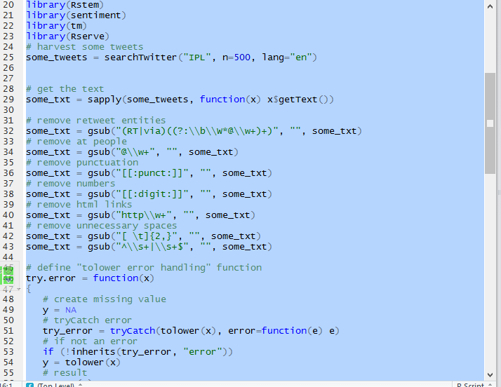

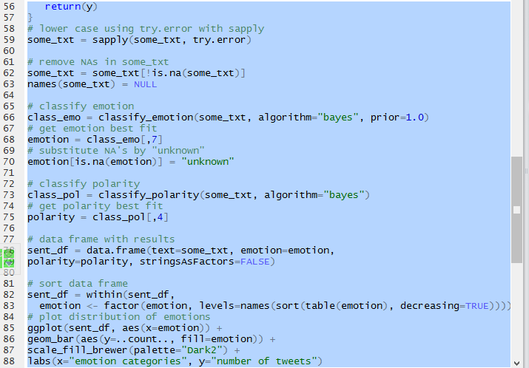

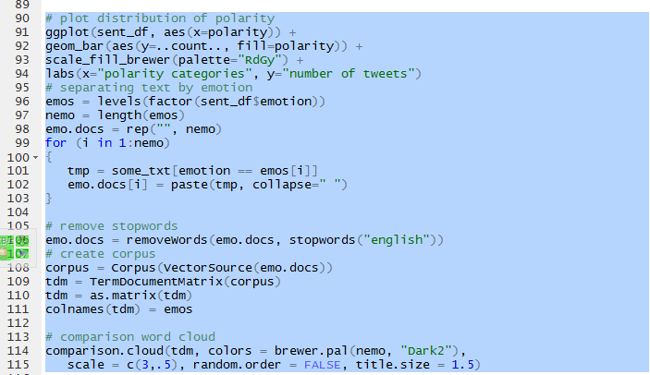

Result for Sentiment:

Emotion:

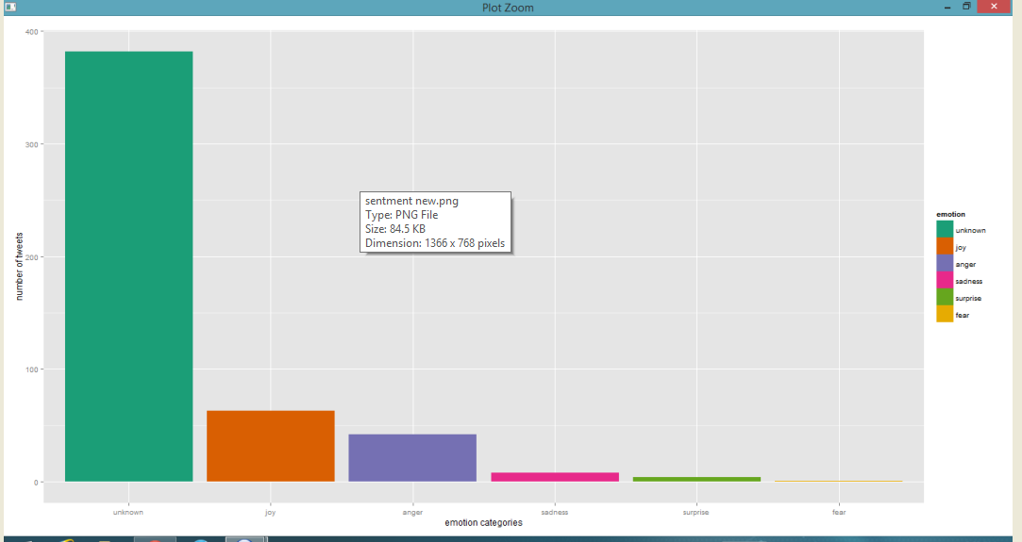

Polarity:

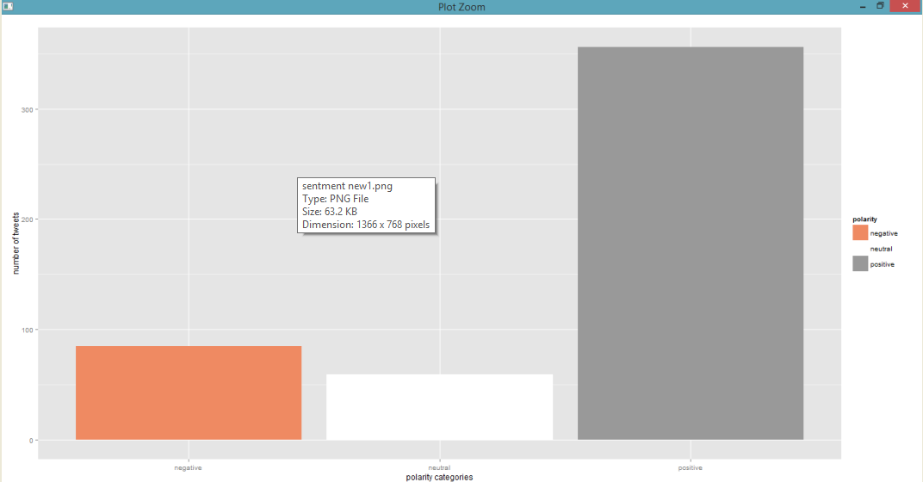

Wordcloud for Sentiment analysis:

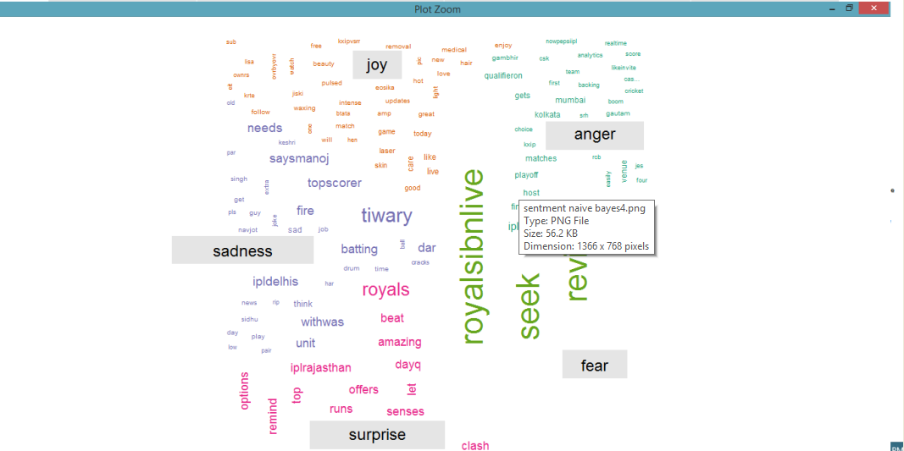

**4.8 Text Mining with Machine Learning Techniques:**

We will take as positive and negative words to score sentiment:

Text mining technique has been already discussed before:

So we have to do first is to download dataset of positive and negative word in csv, txt or xlxs file and then we have to load those dataset to perform positive and negative score.

We have to call some package as follows:

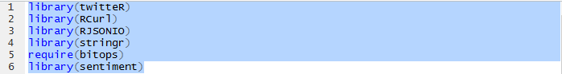

Here twitter is optional, if you want to get tweet directly from twitter then it is necessary to use twitteR API and we can use code given below.

First step I have done here is I have loaded positive and negative words from my computer in R:

Here is the code:

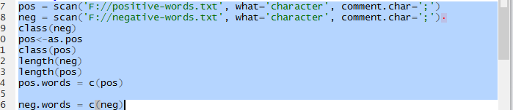

Output:

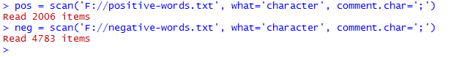

After loading I have done some manipulation by text cleaning method:

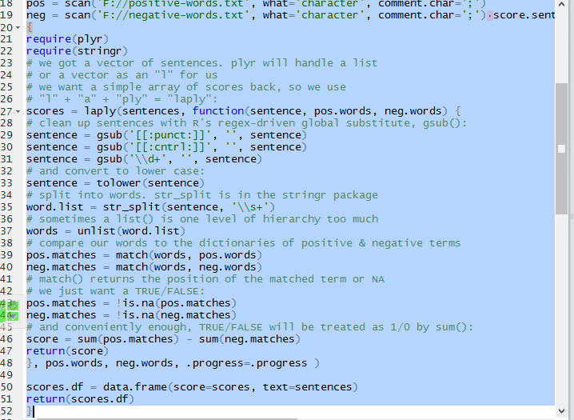

Now we will give some sample data:

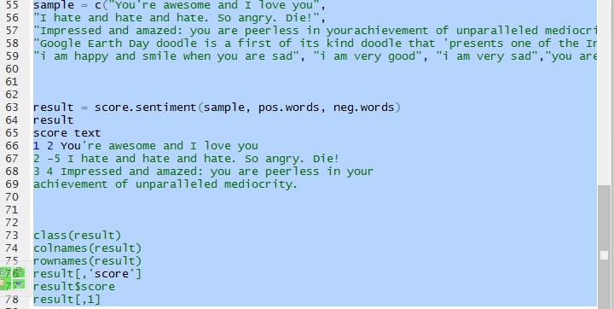

Output:

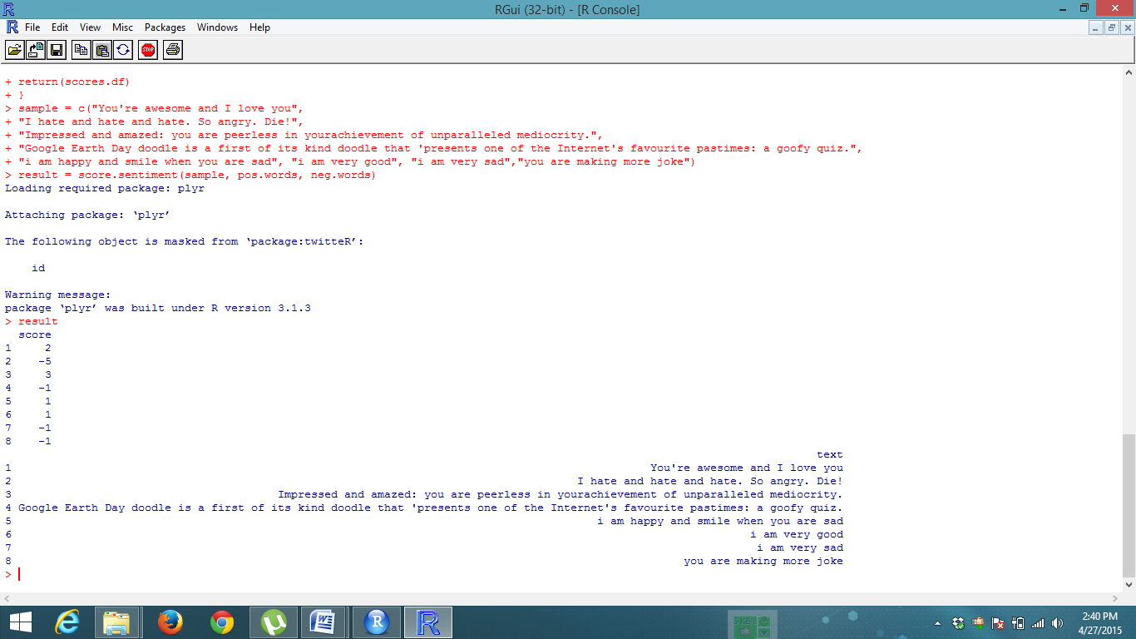

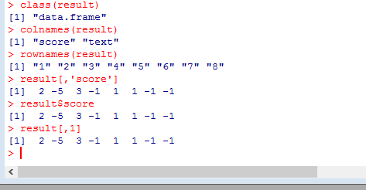

Here I am using some text file. worr.txt and again I am loading this txt in R.

>delta. Text <-scan ('F: //worr.txt', what='character', comment. Char=';')

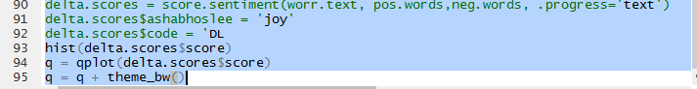

We will get output from R console as:

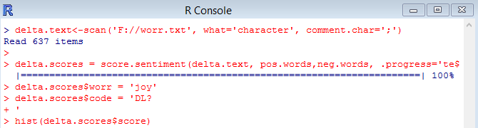

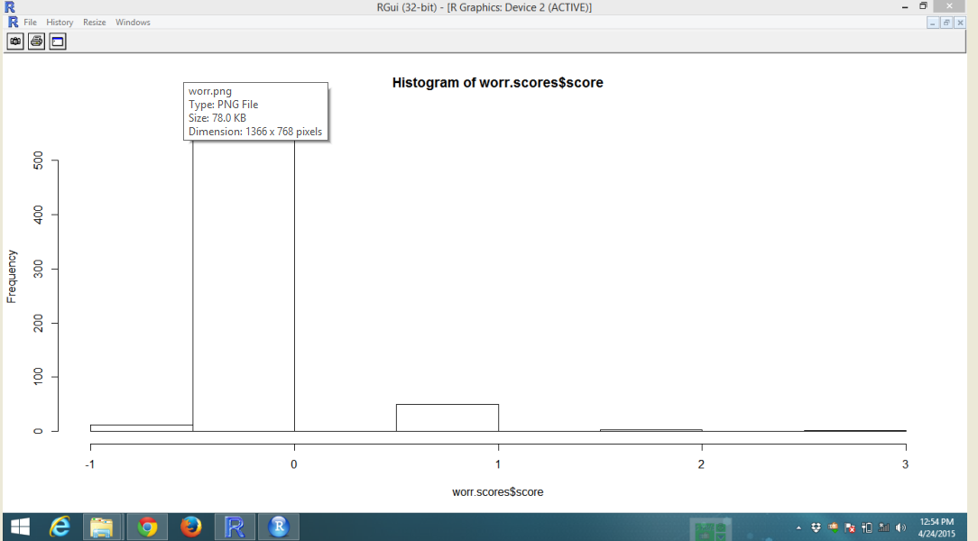

**4.8.1 Visualization of the tweets:**

After accomplishing all the task the sentiments of the user will be able to plot visual histograms and other plots to visualize. This can be drawn with hist function with RColorBrewer package that is used to play with colors. 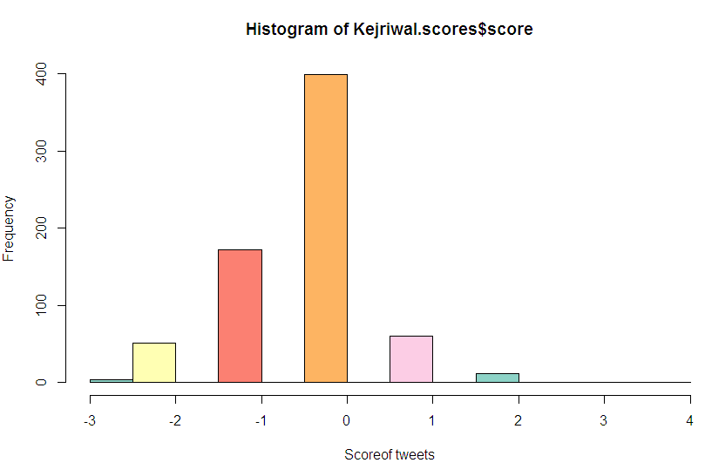

**5. SENTIMENT ANALYSIS USING TABLAEU**

**Tableau is tool which offers a variety of training options to aid you to get various interactive design quickly and attractively with the most out of your data with.**

**5.1 Creating API with Tableau**

First, we access Twitter developer and create an application.  This will generate the oAuth 2.0 keys required.

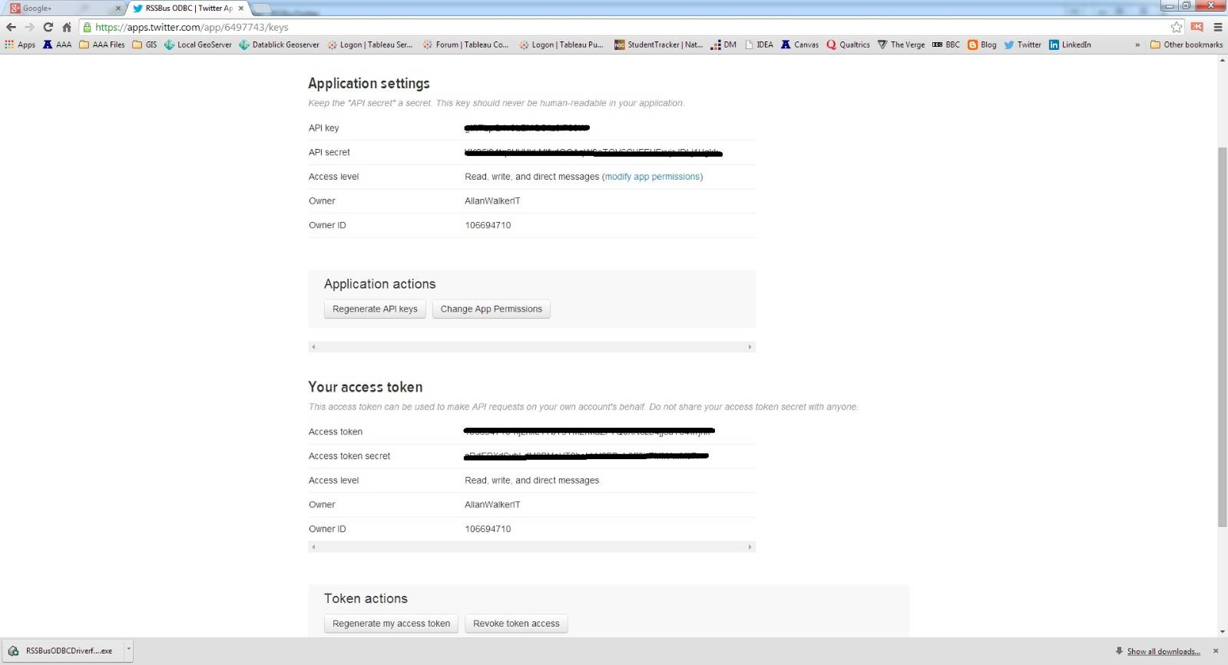

Next, we look at the parameter of Twitter API.  In this case, I'm just going to pull my tweet stream, but it can be changed to whatever you want in the API query syntax.

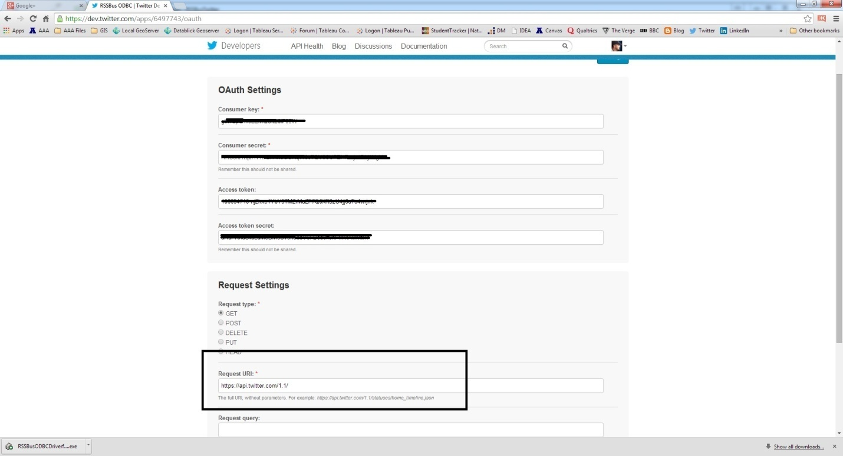

Next up, we download the driver from the vendor (this is a trial version).  We enter the oAuth 2.0.

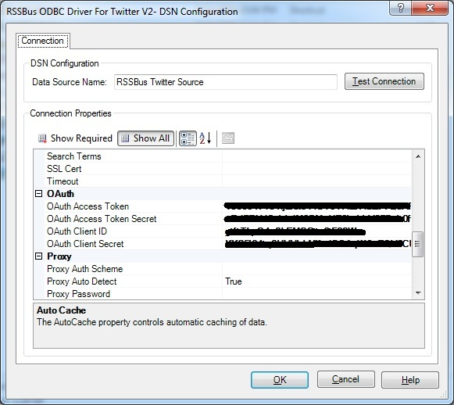

Next, we configure the Generic ODBC driver in Tableau.  You can see here I am connecting to the "Tweets" table.

**5.2 Loading Data**

Steps to follow*:*

We can connect to Twitter or Google Big Query or Dataset from local system and extract it as CSV, txt, xlxs from Dashboard and we can perform different visualization with extracted data.

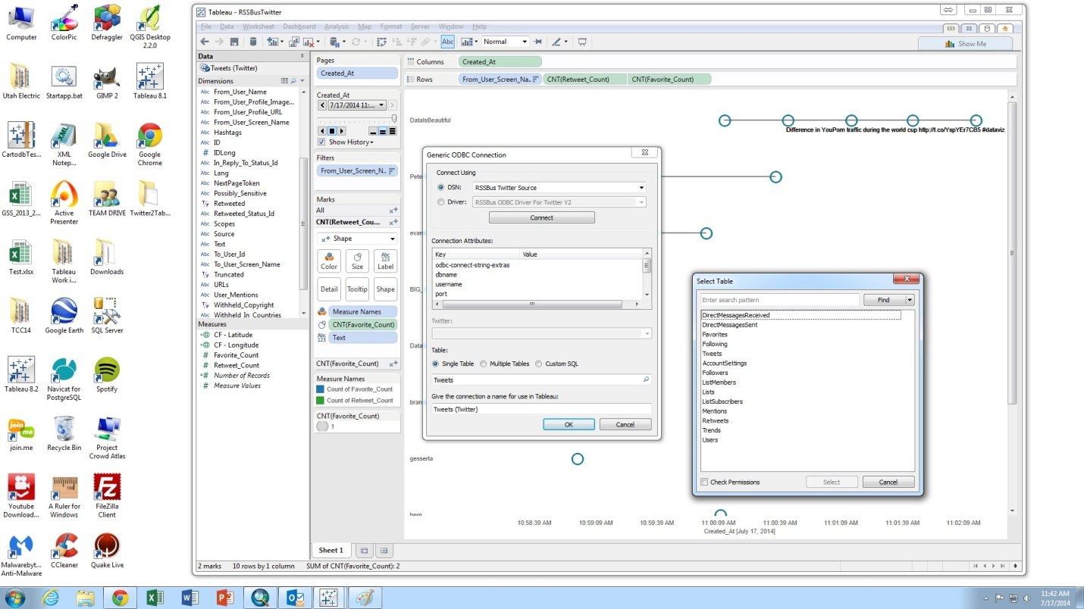

With the increasing amount of user content on the web, text analytics is gaining more mainstream adoption. Sentiment analysis, keyword and named entity extraction are the most common tasks since they allow quickly classifying, filtering and turning text into easily consumable metrics. With the new R integration feature in Tableau 8.1 it is very easy to add these functionality to your dashboards. There are currently two packages in R that can be used for this purpose: sentiment and qdap. In this post we will use sentiment. This package requires tm and Rstem packages, so first you’ll need to install those. You can do this by typing in the commands below, into your R console (or RStudio if that’s the IDE of your choice).

It may be difficult to find the right versions of Rstem and sentiment. If you already have these packages you can skip to the next step. Before you execute the workbook please make sure you load the packages either in the calculation by adding library (sentiment); before the classify_ functions or in Rserve config as covered in my previous blog post about Logistic Regression.

|  |
| --- |
| install.packages("tm")  download.file("http://cran.cnr.berkeley.edu/src/contrib/Archive/Rstem/Rstem_0.4-1.tar.gz", "Rstem_0.4-1.tar.gz")  install.packages("Rstem_0.4-1.tar.gz", repos=NULL, type="source") |

Once you have tm and Rstem installed, here is how you can download and install the sentiment package.

|  |
| --- |
| download.file("http://cran.r-project.org/src/contrib/Archive/sentiment/sentiment_0.2.tar.gz", "sentiment.tar.gz")  install.packages("sentiment.tar.gz", repos=NULL, type="source") |

Let’s take the first stab by using the classify polarity function. Comment Text column contains reviews for a hypothetical product. We are using our calculated field Sentiment for both text and color coding as it returns one of three classifications: negative, neutral and positive.

Now we have to execute some command and R packages. Here Rserve package is for connection between R and Tableau.

>execute. Rserve ()

Now go to Tableau click on Help and click the manage R connection in setting and test the connection and after connecting go and click in measure and you can see new calculated field and in that you can type sentiment and emotion query.

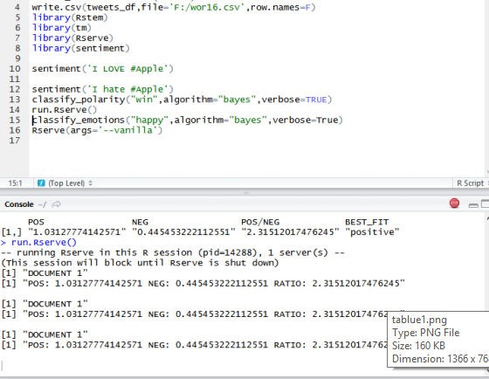

**5.3 Working with Dashboard**

Now Open the Tableau and click on new Server in that select GoogleBigQuery and sign with your exiting goggle account and you can select some dataset from that server or you can select from your file and open the new sheet in dashboard it will show in bottom of dashboard and you can enjoy by doing this.

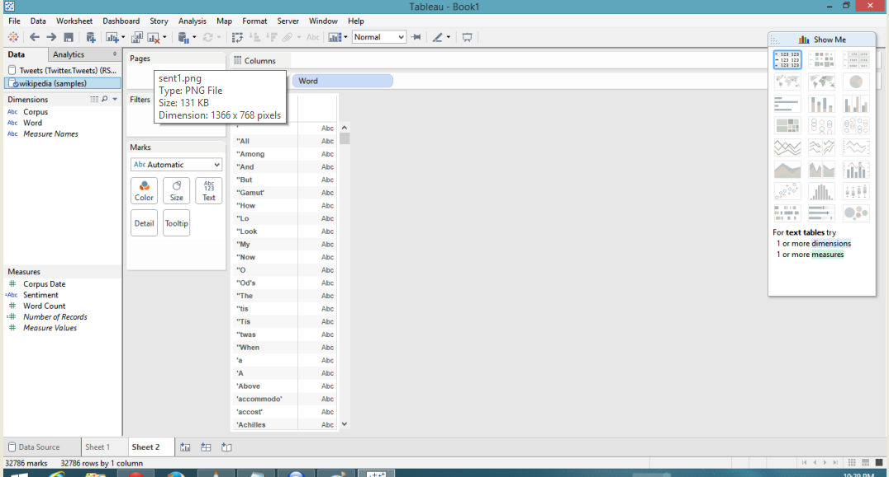

**5.4 Sentiment Score**

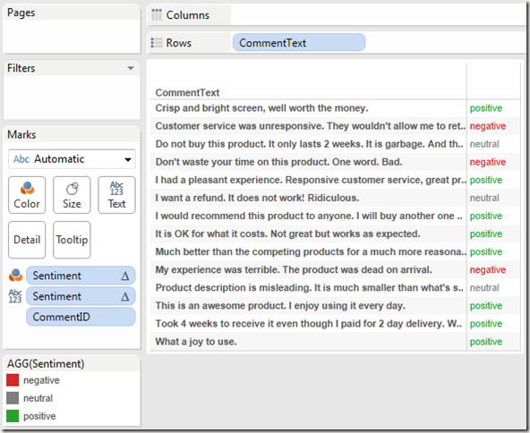

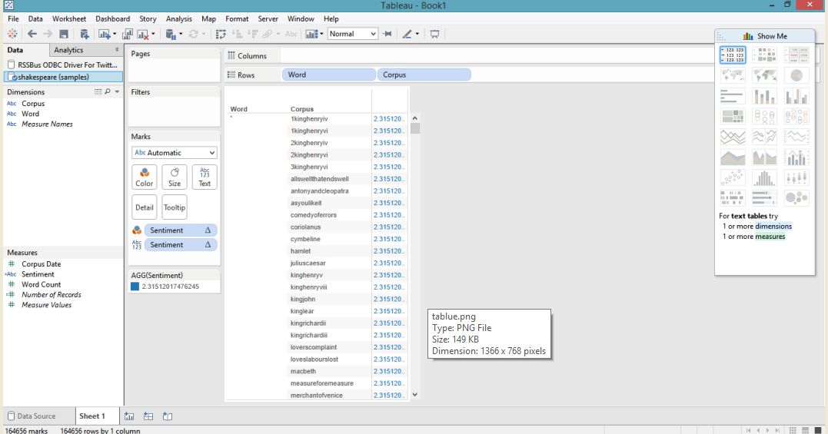

You will notice that the results are not perfect. Second row from the bottom, is in fact a negative comment about delayed delivery but classified as a positive comment. More on that later. Now let’s have a look at what the calculated field looks like.

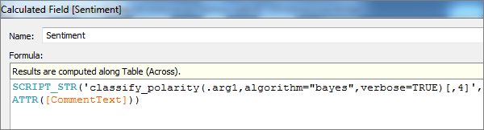

As you can see the R script is very simple. We are calling the function and retrieving the column corresponding to best_fit. Another method in this package is classify_emotion which classifies text into emotion such as anger, joy, fear… The function call is very similar but we get a different dimension from the results this time. Especially the two lines that are associated with emotion “fear” look far off. But how does this work and how can it be made better?

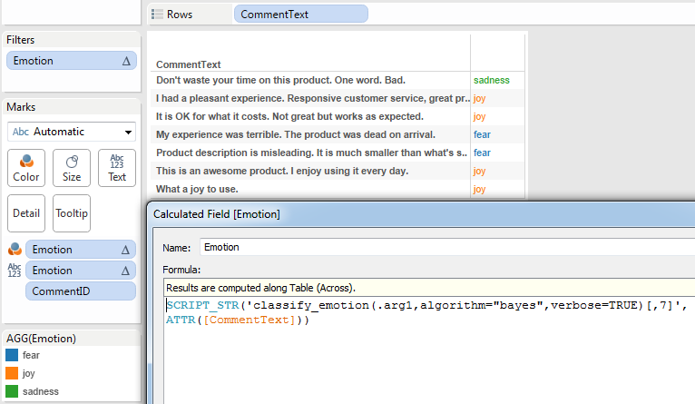

**6. SHINY WEB APPLICATION FOR VISUALIZING**

**6.1 Getting started with shinyapps.io**

Shiny is a web apps (applications) in which a web hosting is done.Shinyapps.io is a platform as a service (PaaS). This steps will instruct you to create a shinyapps.io account and to deploy our first application to the cloud.

Before we get in progress with shinyapps.io, we will need:

RStudio IDE such as R development environment.

[RTools](http://cran.r-project.org/bin/windows/Rtools/) for building packages (for windows users).

XCode Command Line Tools for building packages (*for Mac users*)

GCC (for Linux users)

Install the [devtools](https://github.com/hadley/devtools) R package .The latest version of the [shinyapps](https://github.com/rstudio/shinyapps) R package

Devtools installation

For installation of devtools from CRAN we have to execute the code below. After that restart your R session. The latest improvements uses the devtools package by Shinyapps.io. Firstly we should use shinyapps.io, and we must update devtools to version 1.4 or later.

1. -> install. packages ('devtools')

Installation of shinyapps

Now, we need to install the shinyapps package from its development page at Github and we can do this by executing the R command: Shinyapps package is used to deploy applications to the shinyapps.io service.

Code: devtools::install_github ('rstudio/shinyapps')

After installing shinyapps we have to load in R session

library (shinyapps)

**6.2 Create a shinyapps.io account**

The site will request you to sign in by your Google Account and go to [shinyapps.io](https://www.shinyapps.io/) and click “Log In.” Shinyapps.io heads-up you to setup your account to first time we sign in and Shinyapps.io uses the account name as the domain name for all your apps. Account names may not use with a number or dash, and even cannot end with a dash. So in place of this account names might be used. Every account names should be between 4 and 63 characters and it should contain only letters, numbers, and dashes (-).

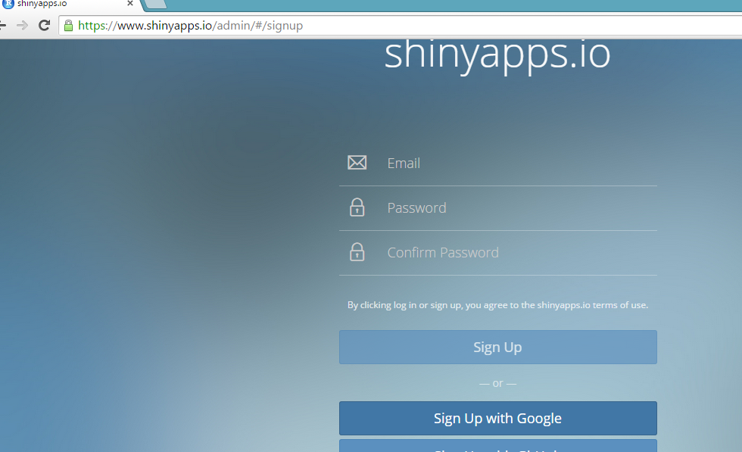

Add your account if you have already goggle account if not then you can create new user.

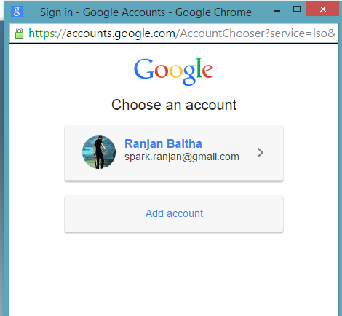

**Configuring shinyapps**

As soon as you set up your account in shinyapps.io, the shinyapps package will helps you to configure to your account. The shinyapps package can use to contact your account and this Shinyapps.io automatically creates a token and secret for you. Now save your token from the shinyapps.io dashboard. Tokens from the menu can be seen at the top right of the shinyapps dashboard.

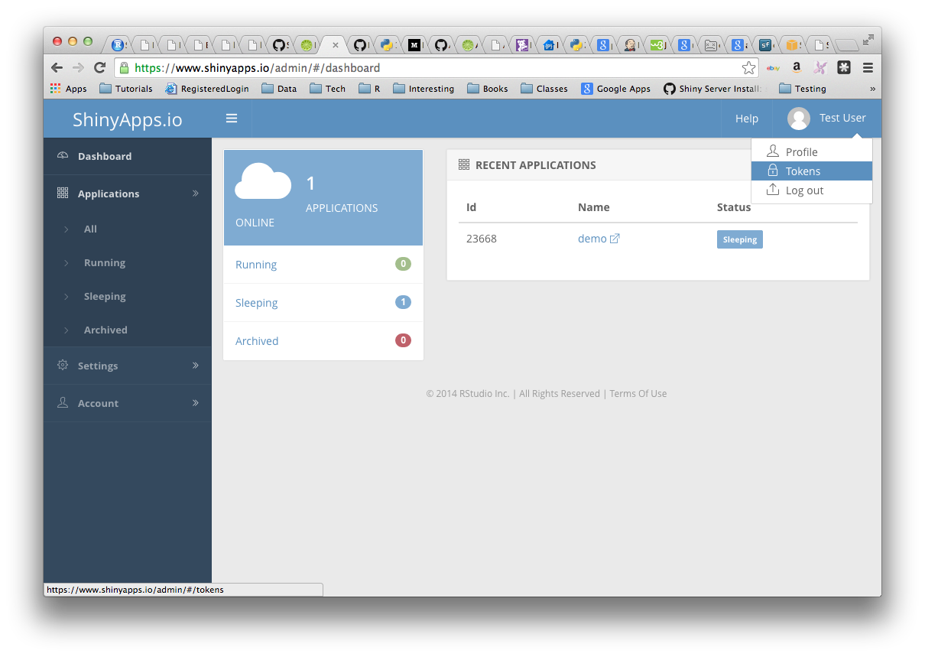

The shinyapps package is used for configuring your account with this techniques:

**Techniques**

Click on the show button in the token page. Now configure your account using the appropriate parameters for the shinyapps::setAccountInfo function on window in which pop up will show and the full command. After that copy this command to clip board, and then paste it into the command line of RStudio and click enter.

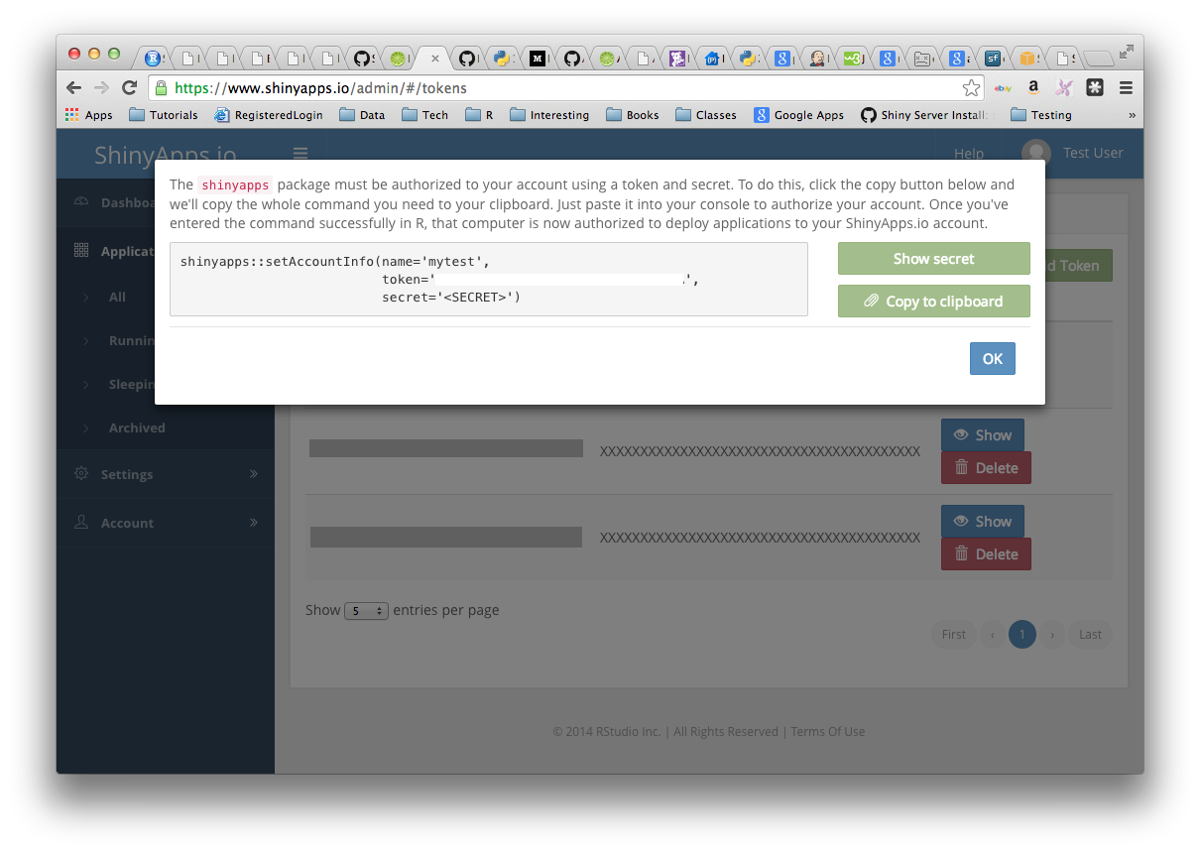

**6.3 Loading API**

An indiacrimeshinny apps

Steps which is required for an RStudio project named “indiacrimeshiny”. Which will contain Shiny application for uploading to shinyapps.io.

Store Data in File called Shiny

Take dataset which is in .rda file from goggle of India Crime against Women and keep in which file is your present working directory or we can change with following command in console.

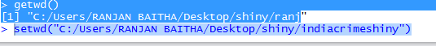

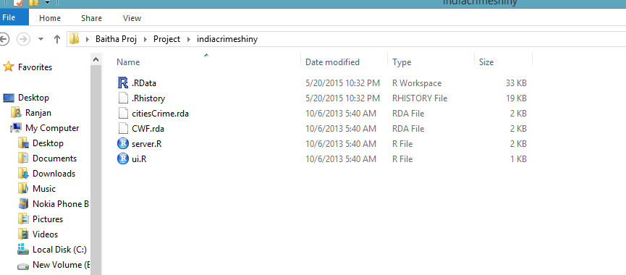

**6.4 Implementation**

Installing the dependencies application

The indiacrimeshiny application will set up with the shiny package and ggplot2 package. Make sure that any package required by the application that will be installed locally before deploying the application:

* install. packages(c ('ggplot2', 'shiny'))

ui.R and server.R

To make your own Shiny application we can cut and paste the code below .We have to place two Shiny source files i.e. ui.R and server.R, in our application .server.R

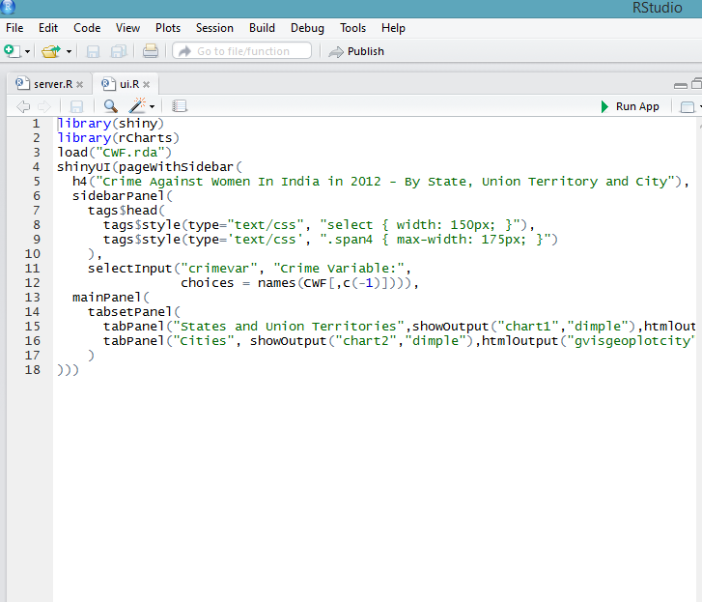

**server.R**

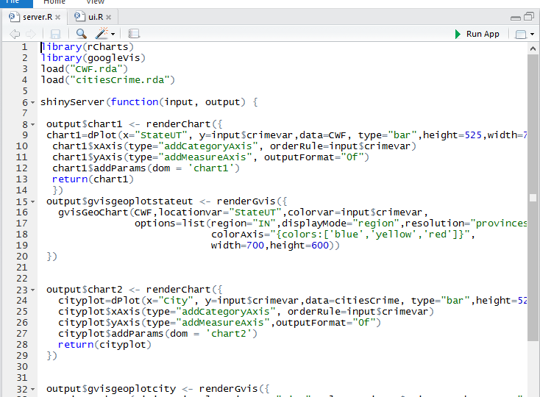

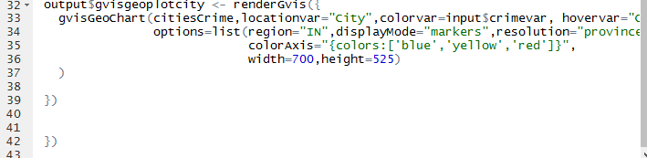

**6.5 Testing the Application**

By executing it locally test t your application that how it works. Make your present [working directory](http://www.rstudio.com/ide/docs/using/workspaces) to your app directory, and then execute:

library (shiny),

runApp ()

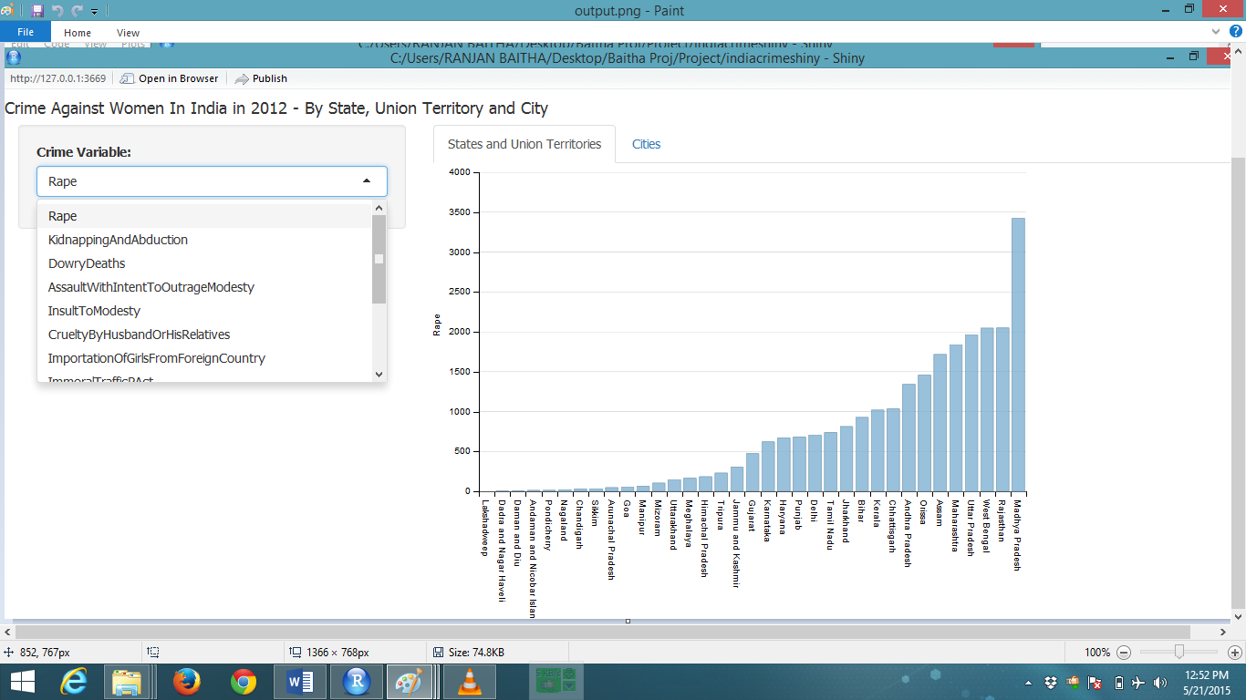After that let’s upload it to shinyapps.io in that application.

Click top of the Rstudio publish button and then we can see our file running in shiny server

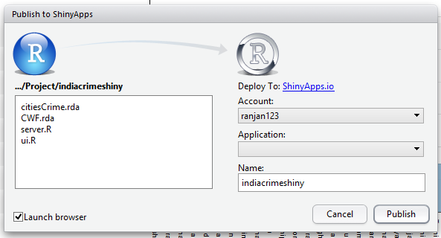

**4.6 Deploying apps**

Now we will use the deployApp command from the shinyapps packages for deployment of your application,

* library (shinyapps)
* deployApp ()

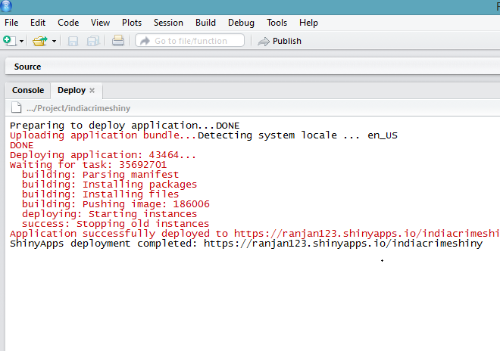After that your browser will open automatically to your newly deployed application for deployment of apps.

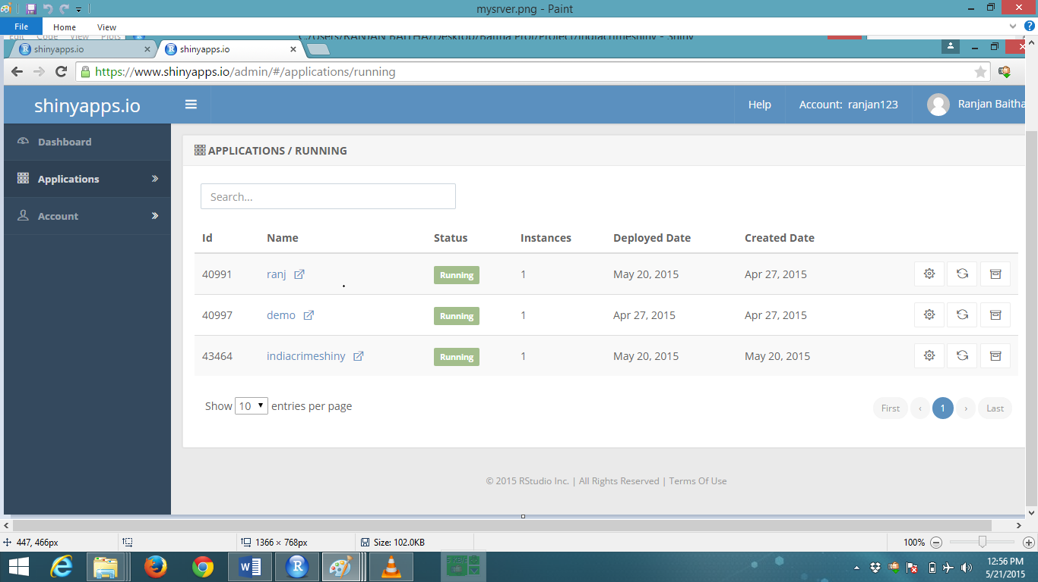

After deploying app we can make modifications to your code and execute deployApp again and then application will execute on server.

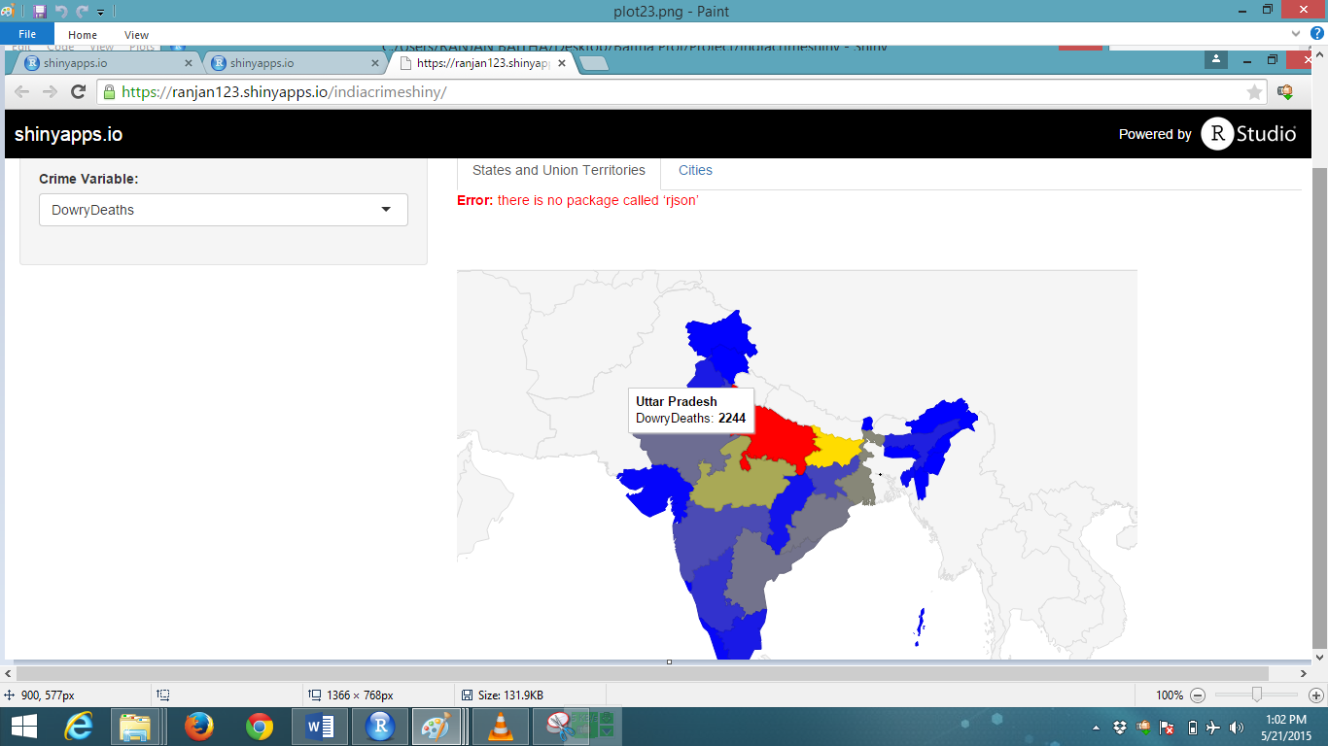

**6.7 Publishing Application**

**Dependencies of Packages**

The shinyapps package is used to attempt for detection of that packages that is used by your application. When we deploy the package dependencies with shinyapps.io service list of package are send by list. When we will deploy our application first time it may use to build packages. Anyhow we will not wait for those packages to integrate during future deployment.

**Logging of Application**

If you have to deploy the application you have to use shinyapps function showLogs () .The log messages of a deployed application will include both stdout and stderr function. It may be helpful to see the log message producing in shinyapps.

**Packages source**

Presently the shinyapps.io service makes deploying packages by installing from BioConductor repositories, CRAN and GitHub to enhance support for R-Forge packages in the future.

**Applications Configuring**

The configureApp function is used from the shinyapps package that can change the request type used by an application. The occurrence type of your application is changed (here from medium to small), execute:

* shinyapps::configureApp ("APPNAME", size="small")

This change will redeploy your application using the small instance type.

The request type used by an application from the shinyapps.io dashboard can also change. For logging in to shinyapps.io, you will choose the application that you have request to configure, and then opening the Settings tab.

**Authentication of Application**

For accessing to your application by enabling authentication with shinyapps.io, you have to log-in with valid credentials and then only it will be able to view or use the app that can be limited for few users.

Here is a sample application with the default visibility settings. To enable authentication in the administrative UI, select the security settings.

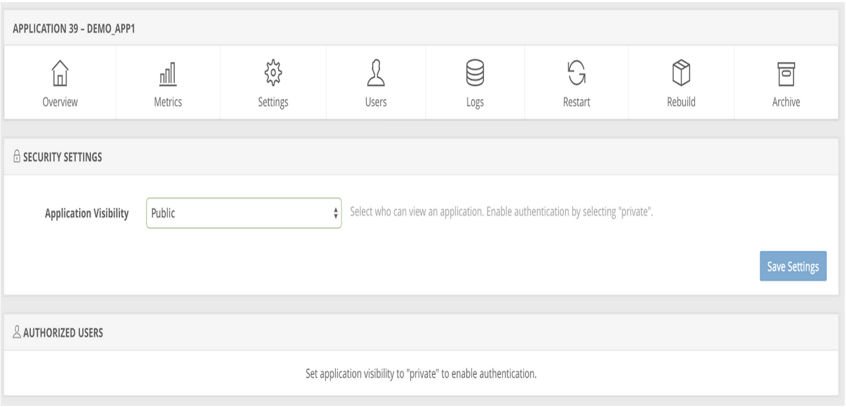

When you will restart your application after authorization you can add user by entering their email addresses and clicking the button Add User. Then after that each user will receive an invitation from your app and if a user does not have signed in app then they can create eventually with the following methods given below:

1. Google Authorizations
2. GitHub authorizations
3. Shinyapps.io authentications

Each visitor to your app will be able to view or use the app if they are authorized user. If they have not been authenticated then Shinyapps.io will prompt password by a username and then only users who log-in with valid credentials will be accepted.

**Terminating an apps**

An app on shinyapps.io from the web can remove with the terminateApp command. To use it, execute

* terminateApp ("<your app's name>")

When you execute terminateApp shinyapps.io will close your app, but the app will persist archived in your shinyapps.io account. If you later choose to redeploy your app with deployApp then this will creates adeptness. An app from your shinyapps.io dashboard can also be terminate.

To make log in to shinyapps.io, dashboard select the app that you request to terminate and then click “Archive.”

**For help assistance**

For getting idea and to learn or share information about shinyapps.io, you can visit the [Shinyapps.io goggle group](https://groups.google.com/forum/?hl=en#!forum/shinyapps-users).

**Summary**

Shinyapps.io is an online service for hosting Shiny apps in the cloud. For maintaining the server and hosting the app RStudio takes care of all of the facts which lets you effort on writing amazing apps!

Follow this steps to use shinyApps.io

First install the [shinyapps](https://github.com/rstudio/shinyapps) R package from github.

Secondly you have to create an account at [shinyapps.io](https://www.shinyapps.io/)

Thirdly use the tokens generated by shinyapps.io to configure your shinyapps package.

Then deploy your apps with shinyapps::deployApp

Lastly than terminate your apps with shinyapps::terminateApp

You can also use shinyapps.io to create secure apps, and manage your authorized users.

**7. TEXT MINING WITH HADOOP**:

**7.1 HDFS installation**

HDFS stands for Hadoop Distributed File System, which is the storage system used by Hadoop. The following is a high-level architecture that explains how HDFS works.

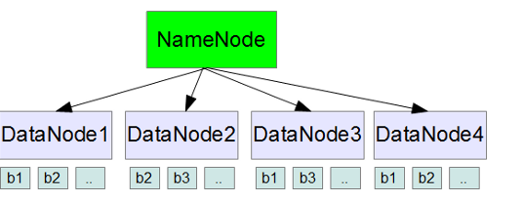

The above diagram, shows NameNode and multiple DataNodes (servers). b1, b2, indicates data blocks.

The several nodes in the hadoop cluster are used to stores them in blocks when you dump a file (or data) into the HDFS. The data blocks distributes them consequently in the cluster and HDFS creates several replication in way that will be dependable and can be retrieved quicker. Multiple nodes across the cluster carry each and every data block that is replicated to Hadoop that will inside make sure that any node failure and will never results in a data loss. A typical HDFS block size is 128MB.

The file system metadata will be on NameNode that accomplishes and there will be multiple DataNodes (They are the real cheap service servers) that will be storing the in the data blocks.

An administrators that work on HDFS it provide a command line interface for Hadoop. The NameNode will get the file metadata information when you execute a query from a client and then it will reach out to the DataNodes to get the real data blocks. HDFS file system has built-in web server from the NameNode that is used for browse and view some basic cluster statistics.

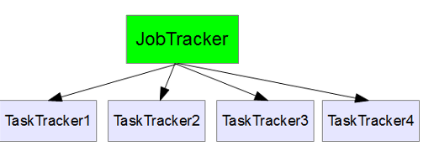**7. 2 Creating HDFS Map Reduce**

**Figure 6**

Map Reduce

A parallel programming model in Map Reduce is used to get the data from the Hadoop cluster in this model, lot of messy details that the library handles programmers doesn’t need to worry about. For example, the library takes care of parallelization, fault tolerance, data distribution, load balancing, etc.

The various nodes parallel executes and the task is splitted thus moving up the multiplication and regaining required data from a huge dataset in a quick manner. Here we have to implement only two functions, i.e. map and reduce

The data that are nourished into the map function as key value pairs to harvest intermediate key/value pairs. This will give a clear concept for programmers. The intermediate results from several nodes that are reduced to create the final output after the mapping is completed.

The Map Reducer jobs that are implementing on several nodes Job Tracker keeps track of all this schedules jobs and keeps track of all the mapper and reducer jobs that implement across the nodes. If any of those jobs fails then it will reallocates the job to another node, etc. Job Tracker also regularly receives a heartbeat message from TaskTracker, which helps JobTracker to resolve whether to give a new task to this specific node or not. TaskTracker finishes the map and reduce tasks that are allocated by the JobTracker.

The framework for processing and storing in big data with a distributed style on big clusters of commodity hardware in an open-source software said to be Hadoop. Basically, it completes two tasks: faster processing and massive data storage.

Two important elements in Hadoop are:

1. Map-Reduce
2. Hadoop Distributed File System

**7.3 Language/Script Used**

**Pig description:**

Pig is an [Apache open source project](http://pig.apache.org/). This means under the terms of the Apache License users can download as source or binary free, by using themselves for support and use it in their products and modification as they will be fit.

The ability for users to develop their own functions for reading, processing, and writing data is done with Pig Latin script that includes operators for many of the traditional data operations by query alike (join, sort, filter, etc.). Hadoop that includes a language, *Pig Latin*, for expressing these data flows Pig provides an engine for executing data flows in parallel.

**Hadoop using Pig**

Hadoop is executed by Pig script. The Hadoop Distributed File System, *HDFS* makes use of both, Hadoop’s processing system and *MapReduce*.

**7.4 Loading data**

By consider a simple map phase, i.e. the “hello world” program of MapReduce in which it will read each line in the text, at one time that counts the number of times each word seen in a given text in MapReduce application. This will divide each word into an isolated string and it will show output as the word for each word to indicate that it has got the word in one time. The hashing the accounts to reducers will use the word as the key by shuffle phase. The reduce part will write together with the word as output and then figure out the number of times each word that text has seen. Now take some txt or .csv file “Batting.csv” .Our input will be:

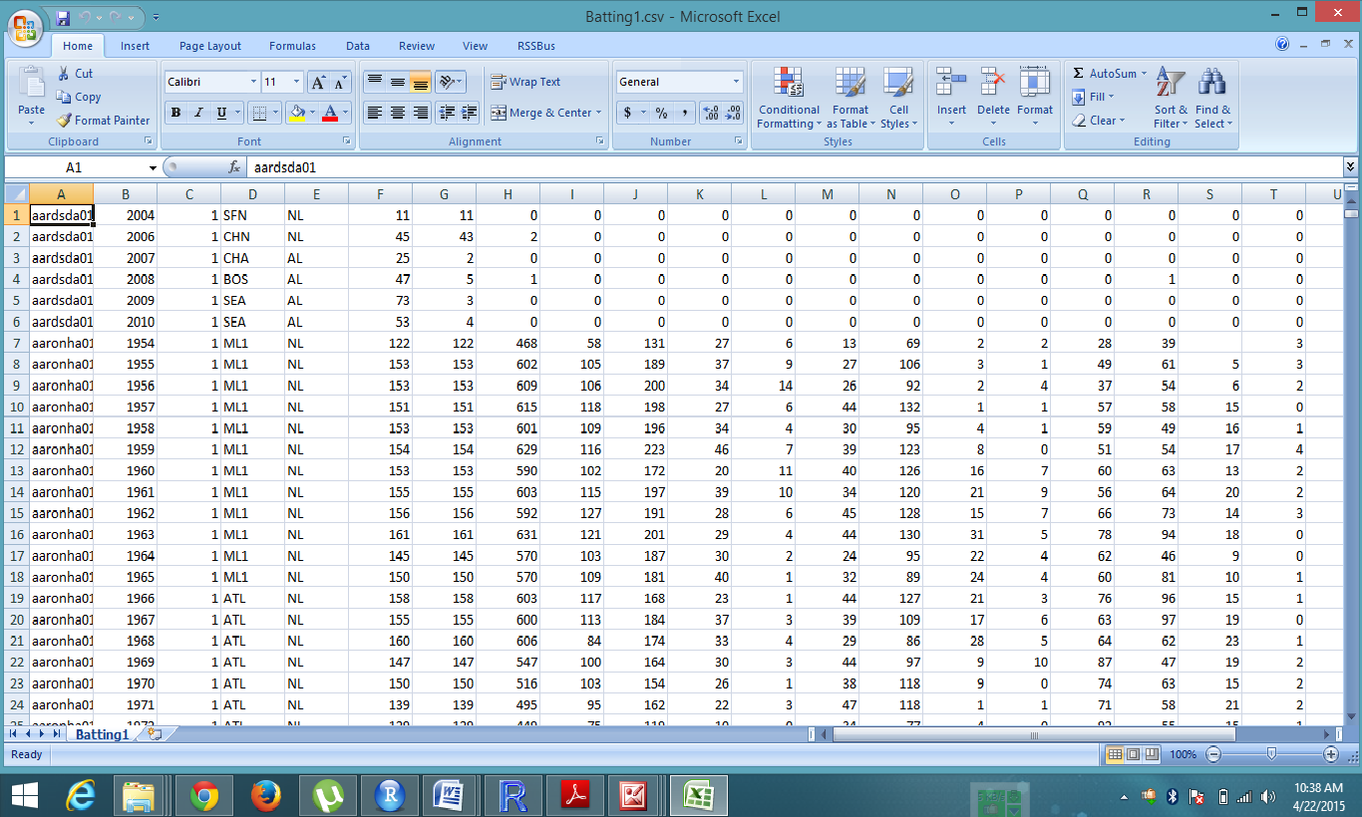

    .

MapReduce is shown in Figure 6 of data flow through each map is assigned much more data than this will sent to a different map task by assuming in each line. Once the map phase is complete, the shuffle phase will collect all records with the same word onto the reducer. For this we will assume an example that there are two reducers: all words that begins with A-L are sent to the first reducer, and M-Z are sent to the second reducer. After that reducer will summed for output.

MapReduce jobs will be executed by Pig script. It uses MapReduce to execute all of its data processed by Pig Latin scripts that users write into a series of one or more is compiled. Now you can view the table as an example for a Pig Latin script that will do a word count of “Batting.csv”.

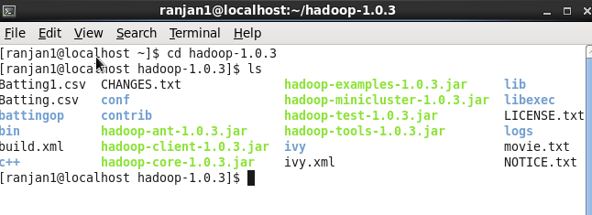

Now start Pig with this command -> pig –x local.

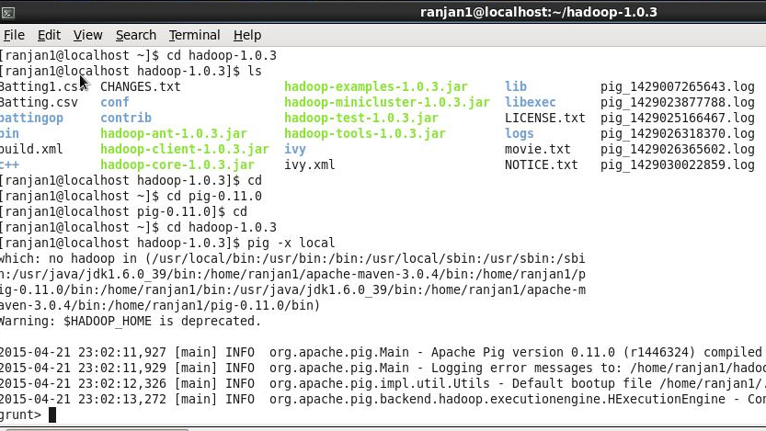

Load the data from Batting csv file in Pig get executed shell:

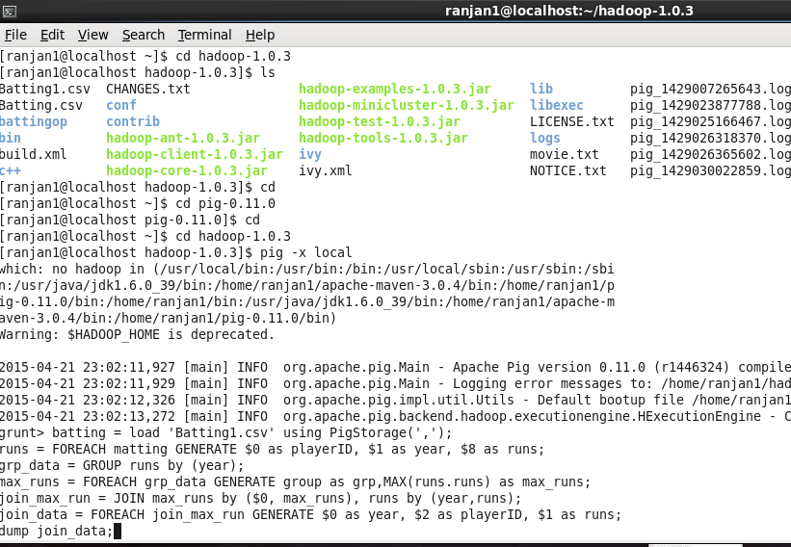

After executing dump command we will get this output:

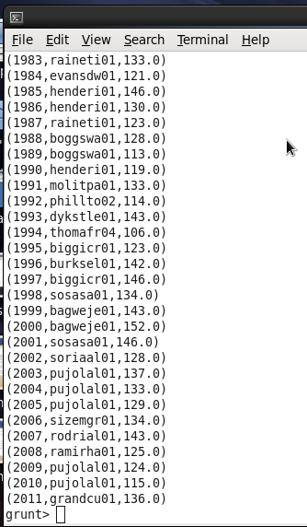

Now store the result as command: - STORE join data INTO ‘Ranjsk’;

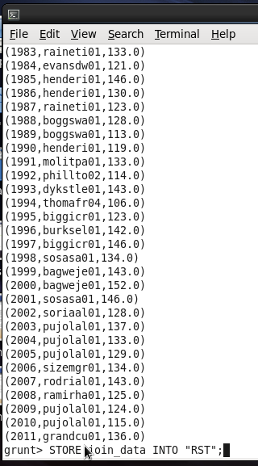

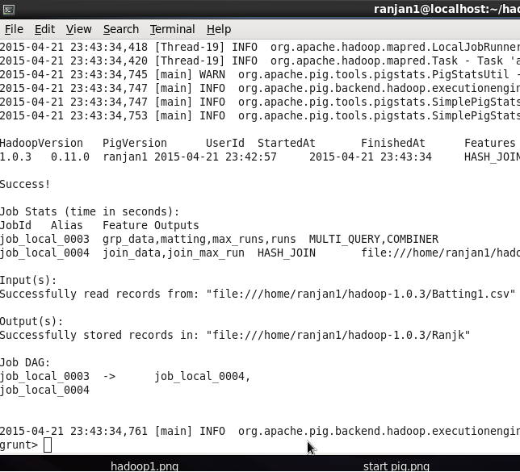

Now to see stored file in HDFS:

First type Quit; to come out from pig:

Then type this command in Hadoop directory:

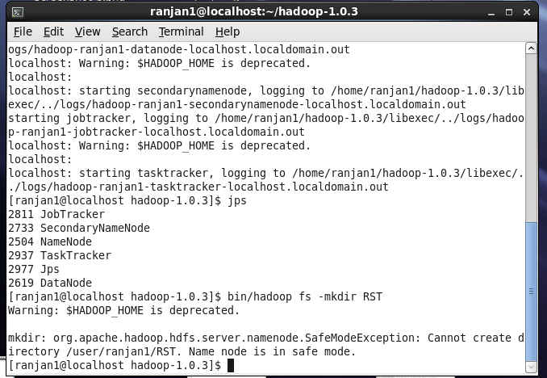

Now copy Ranjsk to new directory in RST of HDFS:

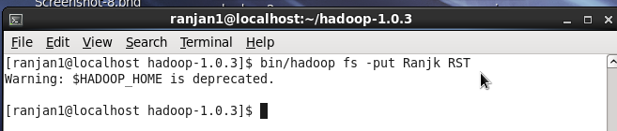

Now open the HDFS by clicking Mozilla browser and type local host 50070:

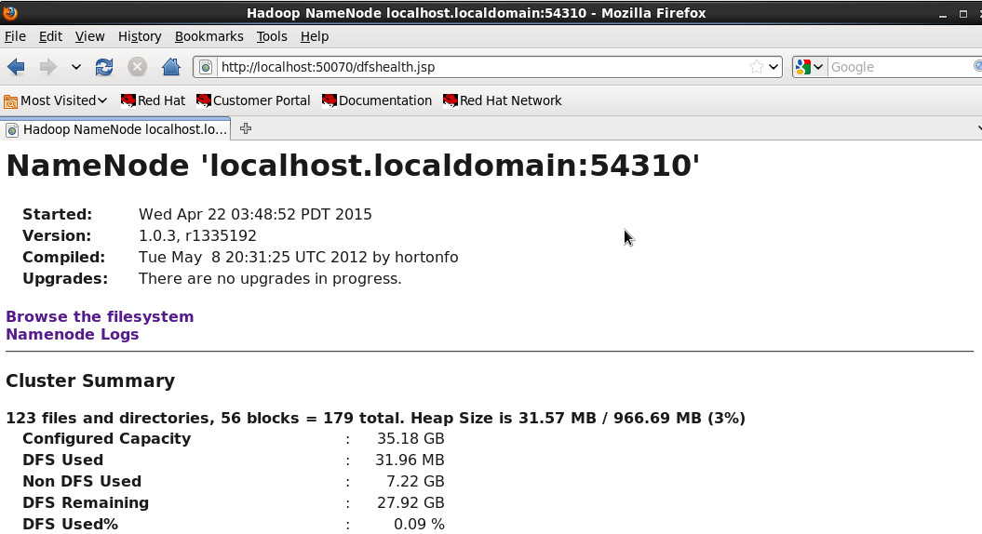

Now click the Browse file system and in that user/ranjan1:

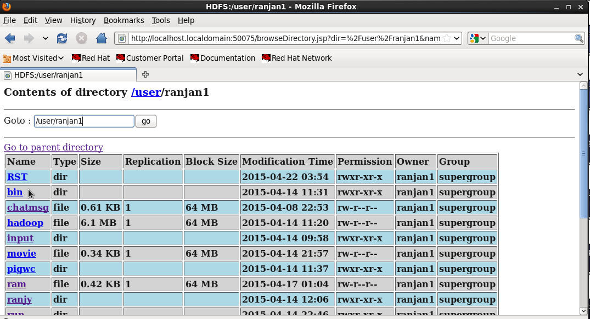

Now see the output in /user/ranjan1/RST/part-r-00000

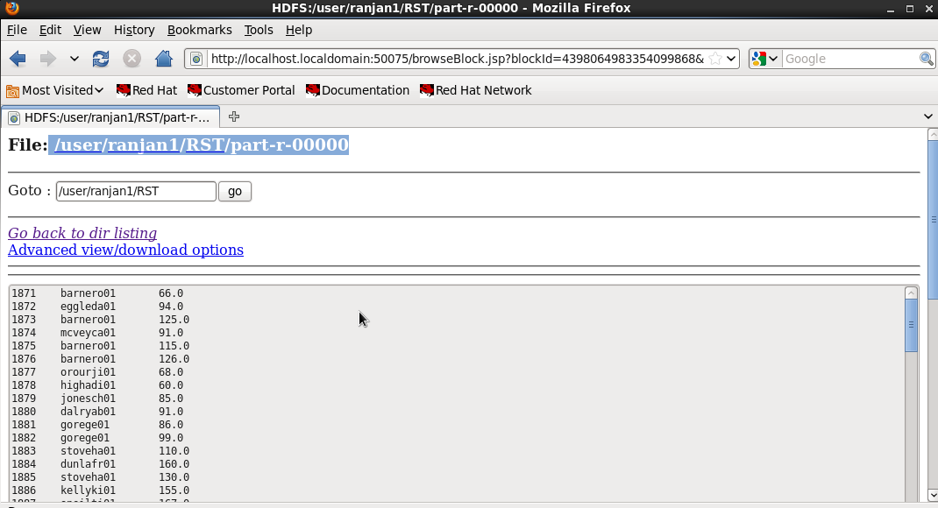

Now transfer your output file in HDFS to local directory:

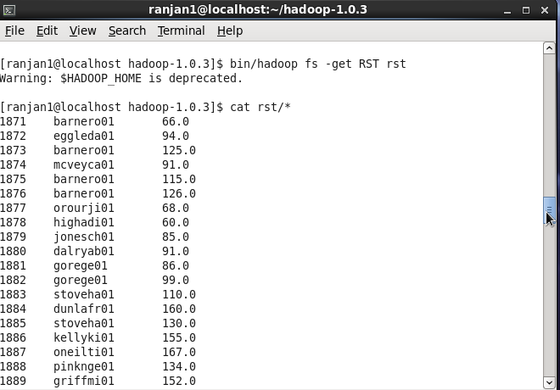

Now you can copy to local file in Linux or download from HDFS file system itself to your local file in Desktop also.

**8. REQUIREMENTS**

**8.1 User Interface**

For this project R studio program is used. R studio is a suitable program that is appropriate for its program libraries and interface encountered as the requests for the brief. In addition to route and easy to understand the user interface of R studio is simple and R studio works fine on both Windows and Mac hardware as it is free and open source.

The user can cooperate with this application because it covers advanced statistical schedules due to these properties the programmer are permitted for best ease and control. R studio can also develop powerful graphics skills which support visualization of data and its outcomes significantly for large, coherent, integrated collection of tools for data analysis.

**8.1.1 Error Notification**

R studio program can have error in which it is necessary for notifications that is required for programmers with suitable messages in red and this will be accessible to the user that will rise in programming which will describe the error. For solutions to the problem error messages can be suggested for the programmer.

**Hardware Interfaces**

The application provides interface and is used for analysis required hardware devices that will execute its hardware devices on a password protected on personal Microsoft laptop.

**Software Interface: Inputs**

The inputs for software will obtain from various sources. Firstly, the programs in R studio and secondly, from the Twitter API, finally from Excel, which will store the dataset once connected from Twitter API, and lastly Twitter app ’ Ranky123’.Twitter API will stream dataset from the Tweet text and program of R studio will source the code outcomes and the majority for the graphs to analyze here ranky123 app will stream which will add a visual element for the interpretation of the data.

**Outputs**

Twitter community will show the current mood of #Dhoni which will send output in the form of a simple charts, word cloud and histograms.

**8.1.2 Functional Requirement**

**Streaming Input**

The software for streaming data will gets from three inputs: R studio code and R studio libraries, Tweets and analysis session duration. R studio code, R studio libraries was obtain by the user for each topic for the analysis session duration that will be set by the user before each session. Twitter API will collected data from the Tweets and saved on an Excel file.

**Processing as Real-Time**

The data provided by Twitter will make authorization and permits current view of the Twitter community’s mood on #Dhoni. This software will take input, process data, and display output in real-time.

**Sentiments Analyzing**

Tweet to determine the whole mood of the Tweets that is relatively for the topic of sentiments analyzing that will be completed by the keywords .The sentiment analysis will generate from collected tweets and results as a negative or positive numeric sentiment value.

**Use Cases**

The present mood of the Twitter Community on #IPL2015 will help for providing users as tool of interest with this software.

**8.1.3 Non Functioning Requirements**

**Performances**

The several software packages that are available in R studio will deliver quick analysis of the data. Latest data is provided by Twitter API are restricted by the rate of Twitter input. The latest outcomes from output should show all times and the user should be informed if it delays. The application should be proficient if the user need to use other applications while operating in the background.

**Availability**

An outer services such as internet access that are essential for functionality of the software will be subjected for the device as it should be working in proper order. The software should be available for the user’s device like laptop and desktop at all times. The user should be informed if those services are not available.

**Reliability**

The software should meet without any unpredicted performance for all the functional requirements. The output should not show improper at any time or invalid data without informing the user for possible errors. In this case error message should be notified to the user.

**Maintainability**

The software normally ensure that maintenance is easy and code is well documented and should be written briefly and clearly. The software will take care particularly for designing.

**Portability**

The software will be compatible and it is developed for all operating systems to confirm the durability of the software. For the proposed to execute on any operating system this software has designed.

**Security**

The software uses passwords and API keys that will make sure to the Twitter API that it should not collect any personal data from its own users and never show any private information of Twitter users. To guarantee maximum security this programs will be implemented on a password secure laptop and desktop.

.**8.2 Design Constraints**

Twitter API is limited and fixed and can return only 1500 tweets at one time. Twitter API has some restrictions such as it sometimes tweets may not be retrieved if there is not sufficient tweets for the particular keyword .

**8.3 Logical Database Requirement**

Twitter will be stored on an excel spreadsheet from tweets that has retrieved. For storing huge amounts of data Excel is an excellent programs for R Studio to upload the data easily. the score of the tweets is single in each row and will characterize the data that will separated with two columns, first column will score the tweets ( neg, pos , very neg and very pos), second column will store the actual collected tweet.

**8.3.1 Dataset**

Twitter’s public timeline in immediate is used to obtain tweets from Twitter API app. A twitter tweets is used for creating dataset by using a topic that was leading or popular twitter for data collection at that time; #Dhoni and #IPL2015.

IPL2015 has not produce enough tweets therefore the focus of the project got fell to returned. Now the tweets from Dhoni which returned 1500 tweets. Generally, collected tweets have lot of slang words and misspellings and it is performed with a sentence level for sentiment analysis. There are three stages. In the first stage sentiment analysis pre-processing is finished by a sentence level .In second stage vector is created which consist more than thousand word words list of happy and sad words and is used for sentiment analysis which done by a sentence level.

The third stage in a sentence level for sentiment in which it uses existing lexical resources as seen in sentiment analysis that provides the bag-of-words approach for number of tweets in each class using sentiment analysis approaches.

These tweets can also refined with Machine learning approaches too. Here the tweets from dataset are split in two training and testing that are used for training and testing so to conduct a Bayesian classifier.

**Creating Datasets**

Twitter dataset are obtainable for analysis by collecting tweets over a period of time ranging from April 16th 2015 to April 18th 2015. Tweets can be poised spontaneously using Twitter API and this can be manually marked as positive or negative. Example, retrieve fresh 1000 tweets that are collected from #Dhoni and 100 tweets were collected from #IPL2015. Surprisingly a number of the tweets were resulted as neutral, though positive and negative tweets and this way the dataset created.

**8.4 Software Specification**

**8.4.1 Hardware Requirement**

Operating System: Window 7/8 and Linux

Processor: Intel Pentium®/AMD

Memory: 512 MB

Disk space: 750 MB of free disk space

**8.4.2 Software Requirement**

R Studio 3.2

VMware Player

WIN SCP

Tableau 9.0

Hadoop

Hadoop distributed file system

Pig

Java JDK 6

**9 CONCLUSION**

In this project a machine learning approaches and crossbreed knowledge based approaches were used by text mining and sentiment analysis. A systematic analysis of the tweets of #Dhoni and #IPL2015 in order to give result which were taken out from Twitter. In First scenario #IPL2015 cannot collect tweets then we focus of the project that was unsuccessful for the tweets that has to retrieve. Now from #Dhoni, in which it retrieved 1000 tweets. A list of happy and sad opinion words or sentiment words for English was used to divide the tweet that can be downloaded from web which is available in sentiment lexicon which contains 6800 words. By using the machine learning Bayesian classifier is used for tweets and then classifies into positive and negative classes. To represent and to understand many graphics like wordcloud, graph and cluster are used by using libraries and package is used in R studio by connecting Twitter with App.

Second approach was by performing sentiment analysis using Tableau which is advanced and dynamically used for interactive design for statically plotting for graphs and **to get various interactive design quickly and attractively with the most out of your data with. Tableau connects with server and by opening in R console runserve () function we can connect Tableau and R and data can be fetched with queries or command. In Tableau data can be accessed from server or other database server and even twitter. In this project GoogleBigQuery is used for sentiment analysis.**

**In this project third methodology is used in interactive web server which is part of Rstudio.** Shiny is a web apps (applications) in which a web hosting is done.Shinyapps.io is a platform as a service (PaaS). This steps will instruct you to create a shinyapps.io account and to deploy our first application to the cloud. In this module application is created using <http://www.shiny.io.com> and logging into account we can publish our work in cloud and can be share. In this code is done in Rstudio itself and shiny package have to install and two main parts of shiny coding is ui.R and server.R and runapp () function is used to run and in this we can create web page automatically and interactively with packages.

Last methodologies in this project is accomplished by using Hadoop map reduce concept. Text mining is done by using Pig script which is no Query language and very powerful. In Hadoop map reduce is done by building HDFS which contain built-in Server where file can be browse. Map reduce concept is used and data extraction is done. NameNode and DataNode part of HDFS. In this project a Hadoop is installed on Red hat Linux OS. A simple text is used for map reduce concept “batting.csv” file is extracted by using pig script and extracted file is loaded in the HDFS and can be extracted by loading or even downloading into the local system from HDFS server.

**10 REFRENCES:**

Two way of data collection:

Own data twitter data

Or

From website data collection

<http://cs.stanford.edu/people/alecmgo/trainingandtestdata.zip>  
  
<https://docs.google.com/file/d/0B04GJPshIjmPRnZManQwWEdTZjg/edit>

Here we used both like

First one is own data. i.e. is IPL2015 data

Second one is players review data from twitter.

<http://www.ThinktostartR.com>

<https://www.shiny.rstudio.com>

[www.tableaumining.com](http://www.tableaumining.com)

Cran.r-project.org

Aye.comp.nus.edu.sg

[www.slideshre.com](http://www.slideshre.com)

[www.stackoverflow.com](http://www.stackoverflow.com)

static.com

[www.tablueausoftware.com](http://www.tablueausoftware.com)

[www.trap.ncril.ie](http://www.trap.ncril.ie)

**11 APPENDIX**

**11.1 Project Proposal**

**Aim and Objectives**

The aim and objectives of this project is to use to ensure a systematic approach for machine learning techniques analysis for the dataset and outcomes from the knowledge based techniques. The creation of a proper dataset from tweets it needs to be built Twitter API which is an app and used for extracting tweets from twitter and loads them into a dataset in order to do any kind of analysis on twitter.

This project will normally use machine learning methodologies which is a more likely approach for sentiment. It uses a hybrid of knowledge based sentiment analysis methodologies which have been more used in analysis of the dataset for outcomes of those two methodologies that will be used to complete systematically.

**Resources required for construction**

These are dependent libraries in R studio

* Twitter API
* A Personal twitter account.
* Excel

Existing sentiment lexicon for complete data abstraction.

**Requirements Specifications**

* Data for retrieval
* Data for analysis
* Statistics and algorithms
* Literature and review
* System and Architecture
* Editing

**Technical Details**

Tweets needs to be made by building a proper dataset. For extracting the tweets from twitter and storing them in a dataset is done by Twitter API app. Besides this project in R studio the following libraries and packages were used;

**twitteR;**

It is a Twitter API which provide an interface for twitter and R Studio.

**rOAuth;**

In this package an interface from the OAuth 1.0 specification is provided, which permits users to verify via OAuth from the server of their choice.

**plyr**:

It is a set of tools that solves a common set of problems: we need to break a big problem down into manageable pieces, operate on each pieces and then put all the pieces back together.

**stringr:**

It is a set of simple packages that make R's string functions more reliable, simpler and easier to use. It does this by confirming that: argument and names (and positions) are dependable, all functions deal with NA's and zero length character properly, and the output data structures from each function matches the input data structures of other functions.

**ggplot2:**

It is an implementation of the grammar of graphics in R. We can build up a plot step by step from numerous data sources. It bind and gains both base and lattice graphics: conditioning and shared axes which are controlled automatically

**tm**:

It is a framework for text mining applications inside R.

**wordcloud***:*

This package supports in creating pretty viewing word clouds in Text Mining with frequency set.

**e1071;**

This is function for latent analysis which is provided by R studio package, it is to for Support vector Machines and has collection of clustering and deal with Naïve Bayes and Bayesian classifier.

**Systems and Dataset**

This project is outlined by various process of sentiment analysis given below;

* Training Data and Test Data
* Twitter Crawling
* Ranked Topic
* Sentiment Training and Data Preparation
* Document Probabilities and Sentiment Analysis

Estimating, Tests and Analysis. The estimating will be the outcomes of the analysis in the end.

Under the guide or special person for mentor of this project:

Ms. Radha N.

**11.2 Initial Requirement Specification**

**Introduction**

The facility to send mini blogs (tweets) where users can have only in the form 140 character long messages to friends or groups (followers) is by “micro-blogging” site said to be Twitter. In spite of some limitations, people are permitted to follow and read one another’s tweets normally. Thus tweets are by default public and it lets people to feel about definite subjects from tweet that how they realize. Various Web applications is now joined with Twitter and now people can share their feelings more freely and can sent via various social media platforms. For a study and enquiry purposes Twitter is an absolute choice for loading data and opinion mining in diverse fields.

**Purposes**

The purpose of this document is to outline the requirements is to score the sentiment by using twitter which can be easily retrieve from twitter by giving keyword. The sentiment analysis is used for featuring and analyzing the tweets which is followed by various user and their feelings about the particular topic. For reviewing product by brand, news, personality, company stocks, shares can be analyzed for opinion with sentiment present in the tweets of followers.

Various other interactive design and for statics data can be analyzed with machine learning techniques and visualization provide attractive and easy view of data. By using shiny we can publish our works in cloud and it can handle easily with few line coding compare to other language.

**Acronyms, Abbreviations and Definitions,**

API –Application Programming Interface

Tm- Text mining

**Ranked Topics**

An achieving of program that has applied to Twitter will be processed with listed keywords that will be occupied from the data that is extracted from Twitter. The data is separated in order to assume each message that will hold a single model support a source to an abstract level. There are three different categories that has been selected as follows Tweets will be uniformly divided into three sets of text types

Positive; these words define the positive reviews or opinion from the text of #Dhoni or any product if user want to choose and scoring is done by Bayesians classifier algorithm.(these can be negative for others groups or followers)

Negative; these words define the negative reviews or opinion from the text of #Dhoni or any product if user want to choose and scoring is done by Bayesians classifier algorithm.(these can be positive for others groups or followers)

Neutral; those text from tweet which do not give any opinion are sated as neutral.